

**Gold Futures Market Analysis Report**



Applied Analytical Models (10204412)

Section Number: [**1**]

Student Name: [Saif Kamal Salim Haddad]

Student ID: [21110214]

Table of Contents

1 Feature Engineering 2

1.1 Overview of added features with justifications. 2

1.2 Explanation of how each feature improves the classification model. 4

1.3 Evaluation of feature importance (with appropriate metrics). 4

2 GAN Analysis 4

2.1 Overview of GAN architecture 4

2.2 Generator and Discriminator Loss Comparison 4

2.3 Synthetic Data Evaluation 4

3 Fuzzy Inference System (FIS) 4

3.1 System Description 4

3.2 Sample Analysis 4

3.3 Visualizations 4

4 Advanced Fuzzy Logic System 5

4.1 System Statement 5

4.2 System Design 5

4.3 System Validation 5

4.4 Visualizations 5

5 XAI Framework for Price Movement Prediction 5

5.1 Predictive Models 5

5.2 SHAP Analysis 5

5.3 LIME Analysis 5

5.4 Comparison of SHAP and LIME 5

6 Bias and Equity Evaluation 5

6.1 Model Performance Analysis 5

6.2 Adjustments for Optimization 5

6.3 Performance Comparison 5

7 Time Series Models 6

7.1 Model Parameters 6

7.2 Performance Metrics 6

7.3 Visualizations 6

7.4 Model Comparison 6

References 6

# **Feature Engineering**

## **Overview of added features with justifications.**

Provide an overview of the features added to the dataset, along with justifications for their inclusion. Clearly state how each feature was derived and its potential contribution to the predictive model.

1. **Price Volume Trend (PVT):**

This shows how the price changes are influenced and supported by the number of traders (Volume). It helps us to know if the price is fake or real going up or down, and see the relation of the price changing if it is strong or weak supported by the market.

If a price goes up and many people are trading (high volume), it shows strong demand, which means it is a real going up, but if the price rises with very few trades (low volume), this shows that the rise isn’t stable, and there is no demand.

**EX:** If a stock's price goes up by 5% and trading volume is significantly high, it indicates strong demand for the stock.

**EX:** If a stock’s price drops by 3% with high volume, it signals significant selling interest and a strong bearish trend.

|  |  |  |  |
| --- | --- | --- | --- |
| **Price Value** | **Volume** | **PVT** | **Indicats** |
| Increases | High trading | PVT rises | Buying pressure (Strong Trend) |
| Decreases | High trading | PVT falls | Selling pressure (Strong Trend) |
| Increases | Low trading | PVT is flat or falling | Not Sustainable (weak trend) |
| Decreases | Low trading | PVT is flat or rising | Not Sustainable (weak trend) |

So, PVT helps us see if price movements are reliable and backed by real market activity or not and also helps predict if the current trend (price going up or down) is strong or weak trend.

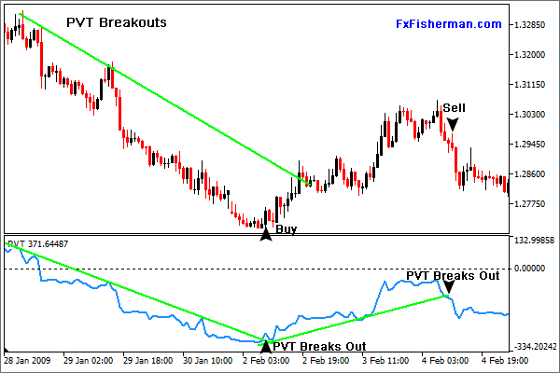

If the PVT moves in the same direction as the price (both rising or both falling), it confirms that the trend is strong and supported by real trading activity.

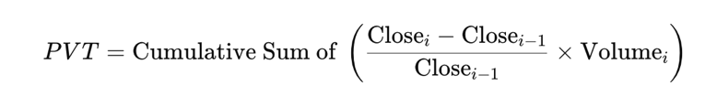**The Formula of PVT:**

**Columns that are needed (Close Price and Volume)**

The closing is to know the price at the end of the trading day.

The Volume is to know the number of trades during the day.

**Step 1: Calculate the percentage price change for this day and the previous day:**

This shows how much the closing price has changed compared to the previous day.

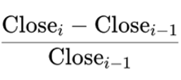



**Step 2: Multiply the percentage change by the trading volume for the same day:**

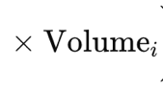This shows the relationship between price movement and market activity



**Step 3: Calculate the cumulative sum of these daily values to derive the PVT:**

This shows the ongoing strength or weakness of the price trend over time

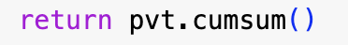

**The potential contribution to the predictive model:**

The predictive model is further enhanced by showing whether price changes are supported by strong trading activity or not, which is essential in defining the reliability and strength of trends. PVT combines trade volume and the percentage price change; these give a clear picture to the model if traders are actively supporting price changes. It helps the model to show early warnings of possible reversals when price and volume are headed in opposite directions (weak trends), which may or may not support, and strong trends where the price and volume agree. By incorporating volume-weighted momentum, PVT reduces the potential for wrong predictions caused by unreliable trends, ensuring meaningful price action that the model prioritizes.

1. **Commodity Channel Index (CCI):**

It is a momentum indicator that works on the principle of determining how far or the difference in an asset's price from its historical average. It may indicate potential reversals or continuation by helping the identification of an overbought or oversold condition. This indicator determines if the present price is abnormally high or low against its average.

**If the CCI value is above +100:** (Overbought Condition) it, indicates the price is significantly higher than the average, this also indicates a downward reversal in the close present time.

**If the CCI value is below -100**: (Oversold Condition), it indicates the price is significantly lower than average; this also indicates an upward reversal in the close present time.

**EX:** If an asset’s price has increased a lot above its historical average, it shows an overbought condition, which means that the prices will fall soon.

**EX:** If an asset’s price decreases a lot under its average, it shows an oversold condition, which means that the prices will rise soon.

|  |  |
| --- | --- |
| **CCI Value** | **Indicates** |
| Above +100 | Overbought (Potential Sell) |
| Below -100 | Oversold (Potential Buy) |
| Between -100 and +100 | Neutral (No strong trend) |

So, the CCI flags when prices have moved too far from their average, which helps the trader to know if it is the right time to buy or sale,

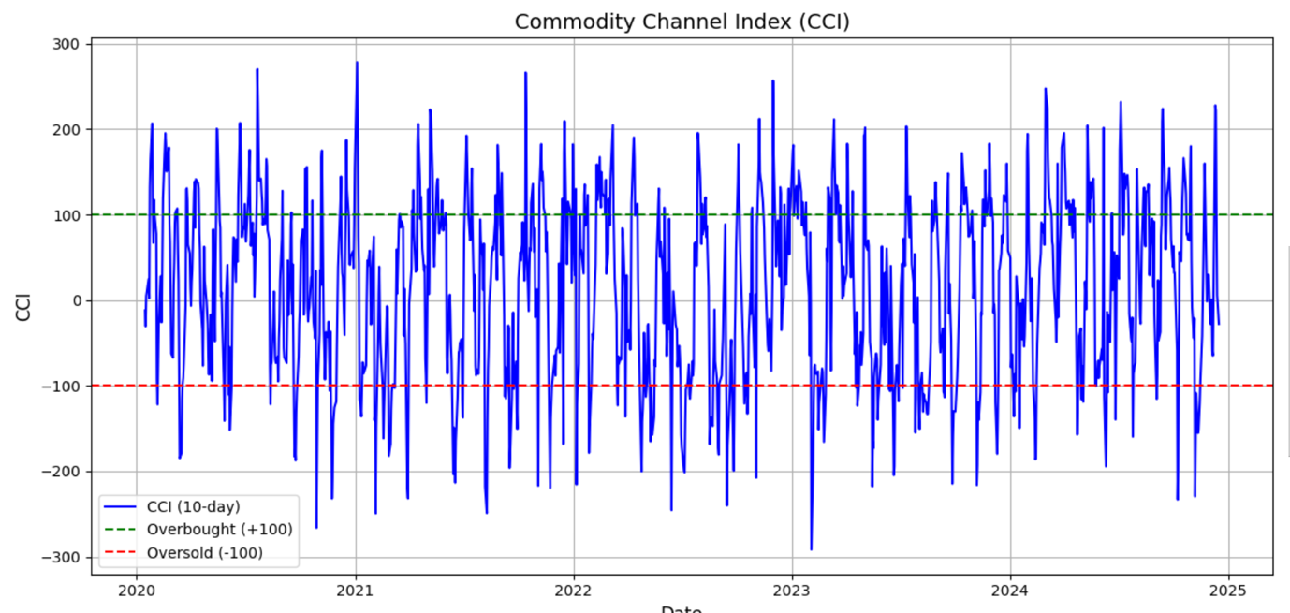

**The formula of CCI:**

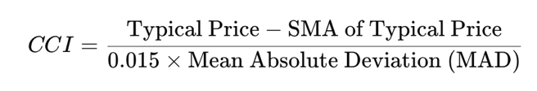

**Columns that are needed:**

High Price: The highest price of the asset for the day.

Low Price: The lowest price of the asset for the day.

Close Price: The price of the asset at the end of the trading day.

**Step 1: Calculate the Typical Price (TP):**

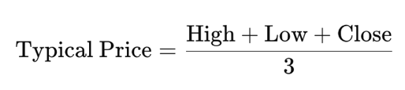This provides an average price for the day.



**Step 2: Calculate the Moving Average of the Typical Price (SMA):**

This provides the Mean of the Typical Price over a chosen window (period of time).

**Step 3: Calculate the Mean Absolute Deviation (MAD):**

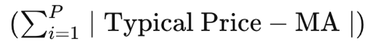This provides the Average of absolute deviations from SMA



**Step 4: Calculate the CCI:**

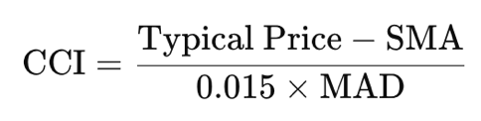The constant 0.015 is a scaling factor to normalize the CCI values.

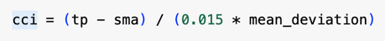

**The potential contribution to the predictive model:**

The above contributes to the predictive model of the target feature, Price Movement, giving critical insight into the price behavior relative to its historical average. Therefore, overbought conditions are identified by the model when the CCI is greater than +100 and the oversold conditions are less than -100. In this respect, it aligns with the momentum of the price and can, therefore, make more accurate predictions about the rise or fall movements in price.

## **Explanation of how each feature improves the classification model.**

Explain how each feature contributes to improving the performance of the classification model. Use metrics and visualizations to support your explanations.

|  |  |  |  |  |
| --- | --- | --- | --- | --- |
| **Features** | **With only (PVT)** | **With only (CCI)** | **With Both (PVT) and (CCI)** | **Without (PVT) and (CCI)** |
| **Overall Accuracy** | 0.83 | 0.85 | 0.85 | 0.83 |

|  |  |  |  |  |
| --- | --- | --- | --- | --- |
| **Features** | **Accuracy** | **Precision (Up)** | **Recall (Up)** | **F1-Score (Up)** |
| **With only (PVT)** | 0.828 | 0.841 | 0.841 | 0.841 |
| **With only (CCI)** | 0.848 | 0.850 | 0.873 | 0.861 |
| **With Both (PVT) and (CCI)** | 0.848 | 0.850 | 0.873 | 0.861 |
| **Without (PVT) and (CCI)** | 0.828 | 0.841 | 0.841 | 0.841 |

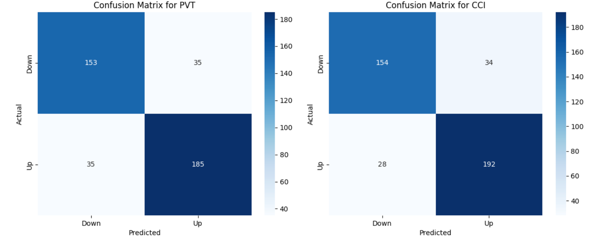

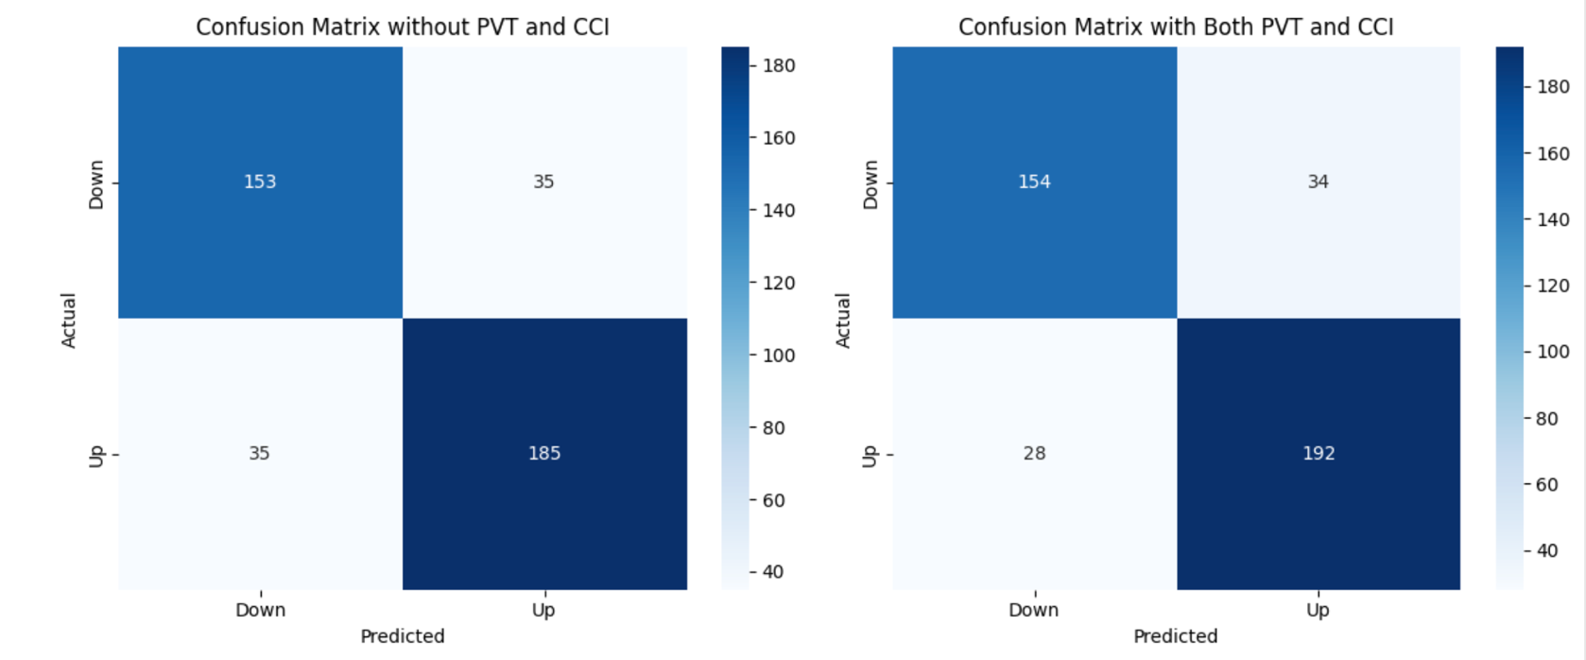

**1. Price Volume Trend (PVT):**

The model using only **PVT** achieved an **accuracy of 0.828** and the same precision, recall, and F1-scores for the "Up" class. These results indicate that PVT contributes to the model by improving its ability to classify price trends based on trading volume.

**2.Commodity Channel Index (CCI):**

The model using only **CCI** achieved the highest standalone **accuracy of 0.848** and the best **recall (0.873)** and **F1-score (0.861)** for the "Up" class.

**3.With Both PVT and CCI:**

The model using **both PVT and CCI** achieved the highest overall performance, matching CCI results with an **accuracy of 0.848**, **precision of 0.850**, **recall of 0.873**, and **F1-score of 0.861**.

**4.Without PVT and CCI:**

The model without both PVT and CCI performed similarly to the PVT-only model, with an **accuracy of 0.828** and the same precision, recall, and F1-scores.

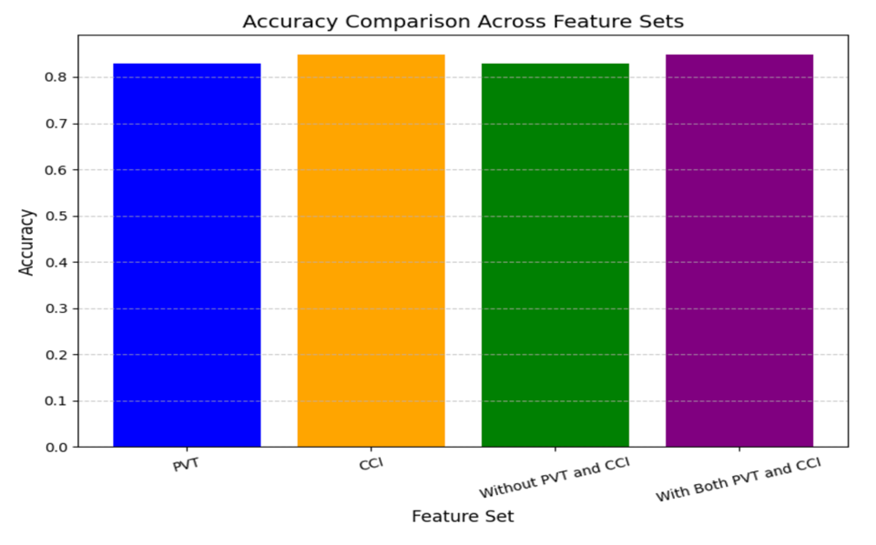

Conclusion:

As we can see from the results, the advanced features that I have added improve the accuracy of the mode. First, I applied the model with both advanced features and without both advanced features. I figured that the accuracy was improved using the advanced features, which shows that these features have helped the model to predict, but after I tried to see the accuracy of the model with each advanced feature that I have added, this time I figured that just the CCI feature has improved the model but the PVT does not add anything on the base model which is without any advance feature.

## **Evaluation of feature importance (with appropriate metrics).**

Evaluate feature importance using appropriate methods. Provide a summary of the most impactful features and their relevance to the model's predictions.

I have used two techniques:

1. **Feature Importance Extraction:**

I used Feature Importance Extraction first to evaluate the features that I added and to see if they would influence and improve the predictions, it was very helpful because it gave me a clear view of each feature’s importance, and from its output, I have decided what leave and what remove from the advanced features that I have added, the features that I was added (Fibonacci, PVT, CCI) but based on the results I decided to remove the Fibonacci feature because the importance of this feature was zero, but on the other hand, using the Feature Importance technique made me know how much the CCI feature is important.

**After Removing Fibonacci**

**Before Removing Any feature**

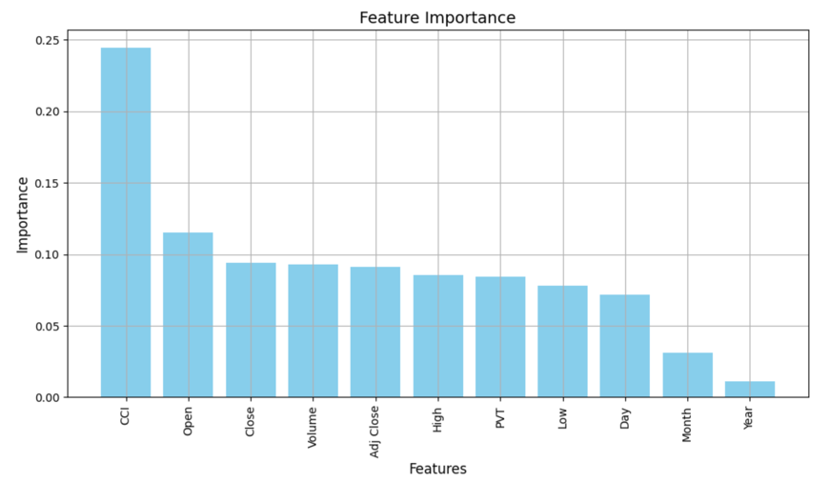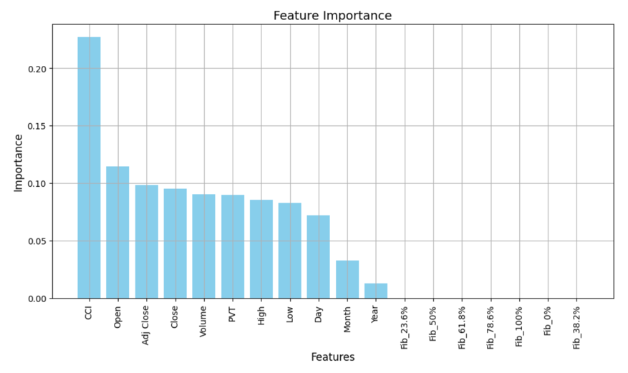

But because when I applied these features to the model to predict, I decided to see how the model would perform with the advanced features and without the advanced features, the sudden that when I applied just the PVT feature to the model, it gave me the same results as the base model without any advanced feature, so I decided to try another feature importance technique which is the Permutation Importance.

**2-Permutation Importance:**

As I said before, I have used this model because the first feature importance technique gave me that the PVT feature is important, but it does not improve the model prediction at all, and it gave me the same results as the base model without any advanced features, but this technique gave me the same output for the Fibonacci feature that this feature importance is zero but the sudden that this technique gave me the PVT feature has a negative importance value which indicates that the feature is either irrelevant, redundant, or harmful to the model's performance.

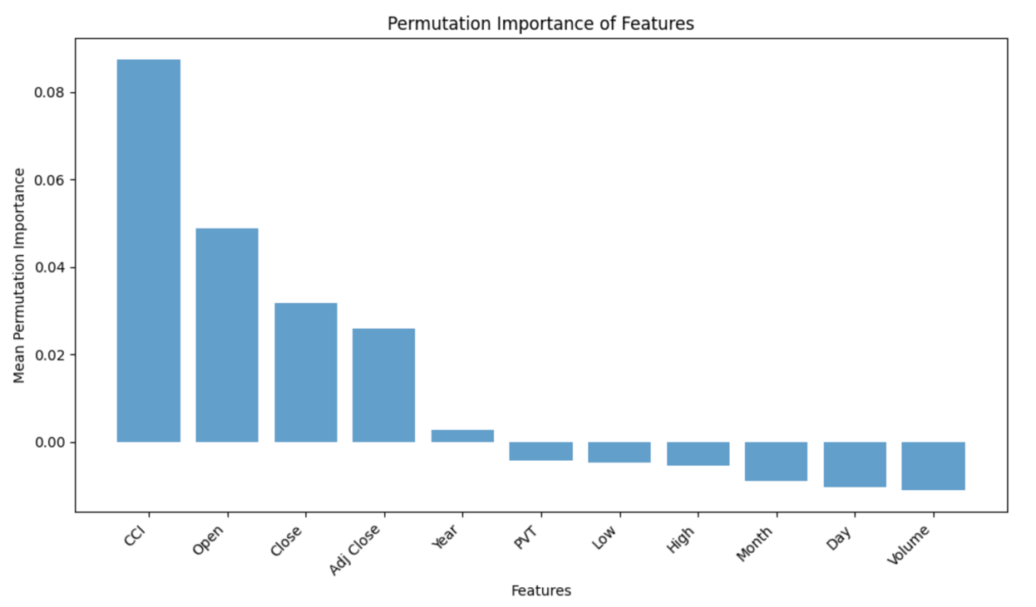

**In conclusion, the most impactful features based on the Feature Importance Technique:**

|  |  |  |  |  |  |  |  |  |
| --- | --- | --- | --- | --- | --- | --- | --- | --- |
| **Features:** | **CCI** | **Open** | **Adj Close** | **Close** | **Volume** | **PVT** | **High** | **Low** |
| **Rank** | 1 | 2 | 3 | 4 | 5 | 6 | 7 | 8 |

**In conclusion, the most impactful features based on the Permutation Importance:**

|  |  |  |  |  |  |
| --- | --- | --- | --- | --- | --- |
| **Features:** | **CCI** | **Open** | **Close** | **Adj Close** | **Year** |
| **Rank** | 1 | 2 | 3 | 4 | 5 |

# **GAN Analysis**

## **Overview of GAN architecture**

Provide a detailed overview of the GAN architecture used. Specify the key training parameters such as: Epochs, Batch size, Learning rate, Input dimension, …… etc.

**What is GAN:**

GAN is a generative model; it is used for creating new data instances (data augmentation), this data that is created is synthetic data that is close and resembles of my training data.

**Fields that GAN helps in:**

**1-Generate images:** Converting a low-resolution image to a high resolution or turning a black-and-white image to color.

**2-Complete missing information:** We can use it as a generative model to accurately guess and complete some missing information in a dataset. Such as generating images of the surface below ground by using the correlation between the two features, which are the surface data and underground structures.

**3-** **Generate 3D models from 2D data:** we can use GAN to generate 3D models from 2D photos or scanned images. Such as X-rays to create realistic images.

**GAN architecture:**

The Gan is made of two neural networks, which are a Generator and a Discriminator. These two are trained together in a competitive framework.

1. **Generator Model:** This model’s main purpose is to generate and produce synthetic data (fake data) that is close to the real data, the model uses a random noise vector, and then takes it as an input value, and then transforms it into a data sample that has the same dimension as the real data, the noise vector is considered as the starting point for the generated values. Inside the generator, there are three connected layers, the first layer has 128 neurons and uses the ReLU activation function; the Relu purpose is to add non-linearity to the model, which allows learning complex patterns and also enables faster training. The second layer has 64 neurons and also has the ReLU activation function, in this layer redefines the features that were generated by the first layer. The last final layer outputs a vector of the same size as the real data (output_dim), also, with the Sigmoid activation function, this Sigmoid activation function ensures that the output values are normalized between 0 and 1 that are the same as the real data scale. In the end, by passing through all these layers, the generator will learn how the outputs must be so the Discriminator

can consider it as real data.

(The generator only learns through the Discriminator's feedback)

1. **Discriminator:**

The discriminator model acts as a binary classifier that evaluates the generator-generated data, whether it is real or fake data. The discriminator works in the opposite way of the generator, the base of the discriminator’s role is to extract features from input data and simplify them so the discriminator be able to accurately classification. The input of the Discriminator (input_dim) shows the size of the input data which is the number of features for the real data or the fake data. the discriminator has three layers, the first one contains 128 neurons with ReLU activation, which allows extracting complex patterns and high-level features that help in classifying the real and fake data. the second layer, which contains 64 neurons and ReLU activation, which works for further processing of the input to catch more features of the data for better classification. The last layer contains one neuron with a Sigmoid activation function, using the activation function ensures that the output is a probability between 0 and 1, if the value is closer to 0, it will be classified as fake, but if the value is close to 1 it will be classified as real. The discriminator is trained alone, separated from the training of the Generator, the way of training it separately maximizes the ability of the discriminator to classify between the real and the fake data.

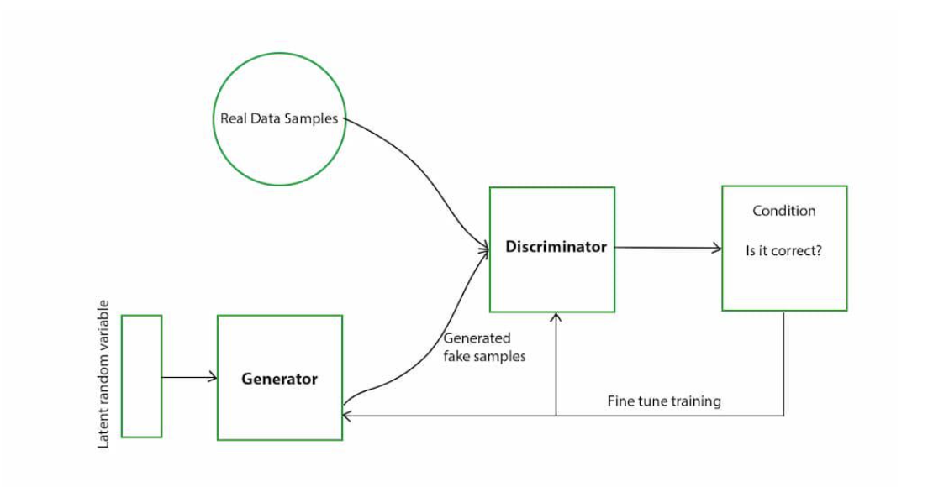

1. **Prepare the GAN model:** In this part contains the Generator and Discriminator. The main function of this part is to train the Generator by using feedback from the Discriminator. It starts by giving random noise through the generator to create fake data, then the fake data moves to the Discriminator, The Discriminator evaluates the fake data and outputs a probability indicating how realistic the data appears related to the real data. The Generator's goal is to maximize the Discriminator's error. This model takes a random noise vector as input, and it generates an output, which is essentially the probability of how likely the data generated is real. The Generator's loss function depends on this probability. It modifies its weights to reduce this loss. And that's actually the adversarial training forcing the Generator to improve its outputs iteratively, making them get closer to the real data.
2. **Training Phase:** the training of the discriminator is different from the Gan model training, at the beginning, the discriminator is trained on a batch of real data (labeled as 1) and fake data generated by the Generator (labeled as 0), this part of training helps the Discriminator to improve the ability of classification. Then comes the part of the GAN model training, this is the period where the Generator attempts to produce fake data that the Discriminator misclassifies as real, this process improves and improves the generator and discriminator over time through running. The discriminator always tries to learn the hidden patterns in the real data so the generator can generate very close data to the real data. The generator uses the feedback from the discriminator when computing its loss, but the discriminator always tries to be better in figuring out the real data from the fake data. this process will run through iterations till the GAN model balances, which means the generator is generating very highly realistic data while the discriminator will try to be very clever at finding small differences.

In the best case, this means that the Generator becomes so good that the discriminator can't tell the difference between real and fake data consistently. Now, the Generator is well-trained and ready to generate new valid data samples.

1. **Generating Synthetic Data:** After the training ends the the Generator is used to create synthetic data samples that resemble the real data, To generate 10,000 synthetic samples and the random noise vectors that were created and then pass through the trained Generator. The Generator outputs data in a normalized format, which is then reshaped and transformed back to the original data scale.

**GAN Working Flow:**

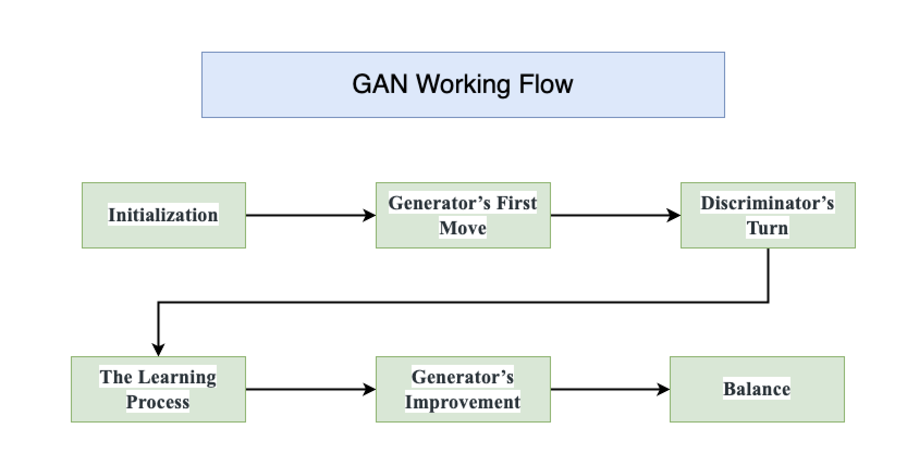

1. **Initialization:** Two networks are set up: the Generator creates new data, and the Discriminator acts as police to distinguish between real and generated data.
2. **Generator’s First Move:** The generator starts by transforming a random noise vector into a data sample.
3. **Discriminator’s Turn:** Discriminator evaluates real data from the training set and data generated by the generator, outputting a score to determine if the input is real or fake.
4. **The Learning Process:** The Discriminator improves by accurately distinguishing real from fake, while the generator learns to trick the Discriminator by creating more realistic data.
5. **Generator’s Improvement:** When Generator successfully fakes Discriminator, it receives positive feedback, refining its ability to produce data that closely resembles real data.
6. **Balance**: The generator generates very highly realistic data, while the discriminator will try to be very clever at finding small differences.

**Main Parameters in the GAN Model:**

1. **Generator input_dim:** Size of the random noise vector input to the Generator. This noise acts as the starting point to generate synthetic data.
2. **Generator output_dim:** Number of features in real data, this is to ensure that the fake data is in the same format as the real data.
3. **Discriminator input_dim:** Number of features in real data or the generated data.
4. **Learning_rate:** The step size for the weight updates during training, used in the Adam optimizer.
5. **Epochs:** Total number of training iterations.
6. **Batch_size:** Number of samples processed in one iteration
7. **Half_batch:** Used to split data into real and fake samples during Discriminator training.
8. **Adam Optimizer:** It’s for Generator and Discriminator, used for weight updates.

## **Generator and Discriminator Loss Comparison**

Compare the Generator and Discriminator loss functions throughout the training process. Use visualizations to highlight their convergence patterns and stability.

**I have made four GAN models, each one with different parameters:**

|  |  |  |  |
| --- | --- | --- | --- |
| **Models** | **Batch_Size** | **Input_Dim** | **Learning_Rate** |
| **GAN-1** | 32 | 100 | 0.0002 |
| **GAN-2** | 64 | 50 | 0.0001 |
| **GAN-3** | 32 | 50 | 0.0002 |
| **GAN-4** | 64 | 100 | 0.0001 |

**GAN-1:**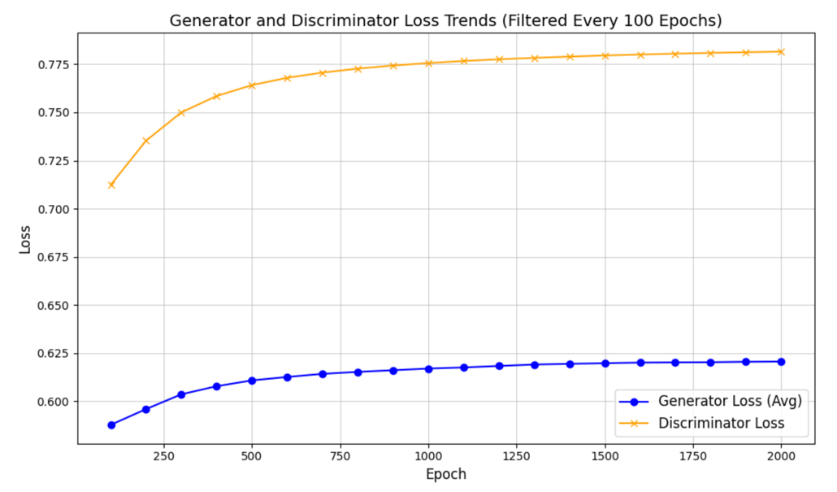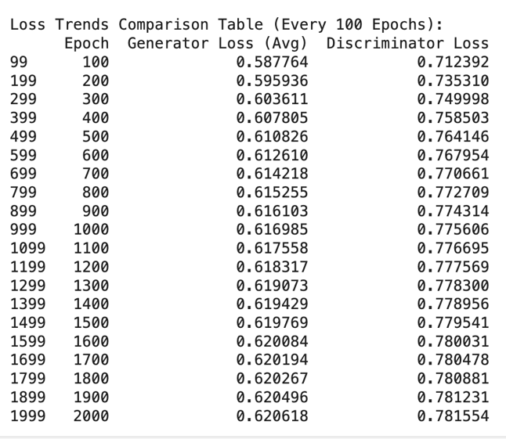

As you can see, the model was very bad. We can see that the discriminator improved over time, but the generator does not improve in generating realistic and close data to the real data

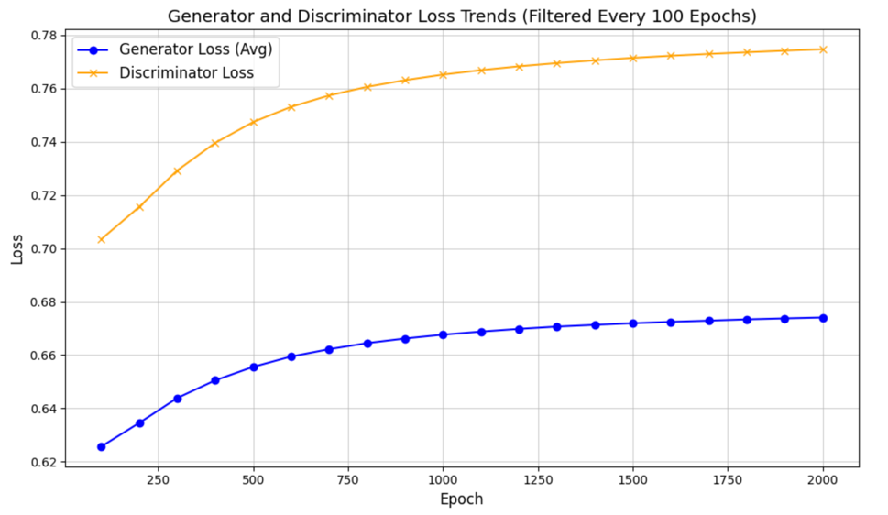**GAN-2:**

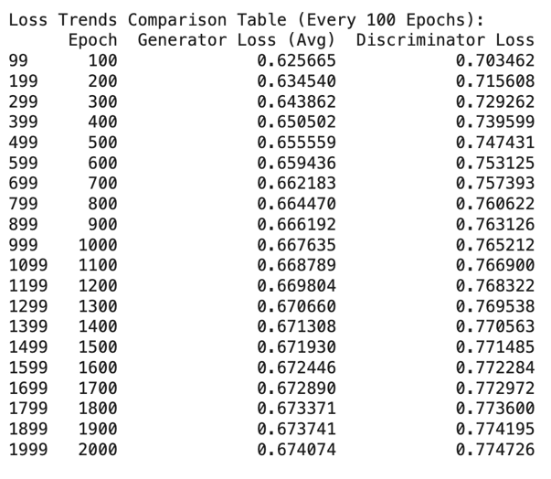

As you can see, the model also was very bad. We can see that the discriminator improved over time, but the generator loss continued increasing, which means it does not generate realistic and close data to the real data.

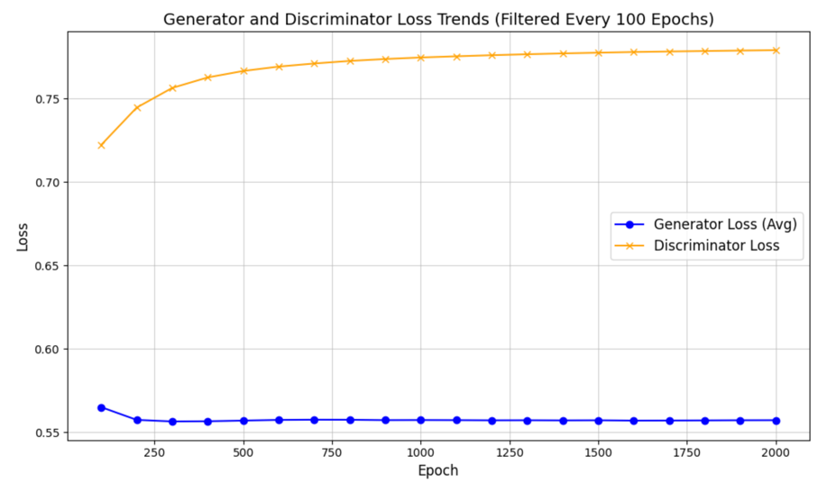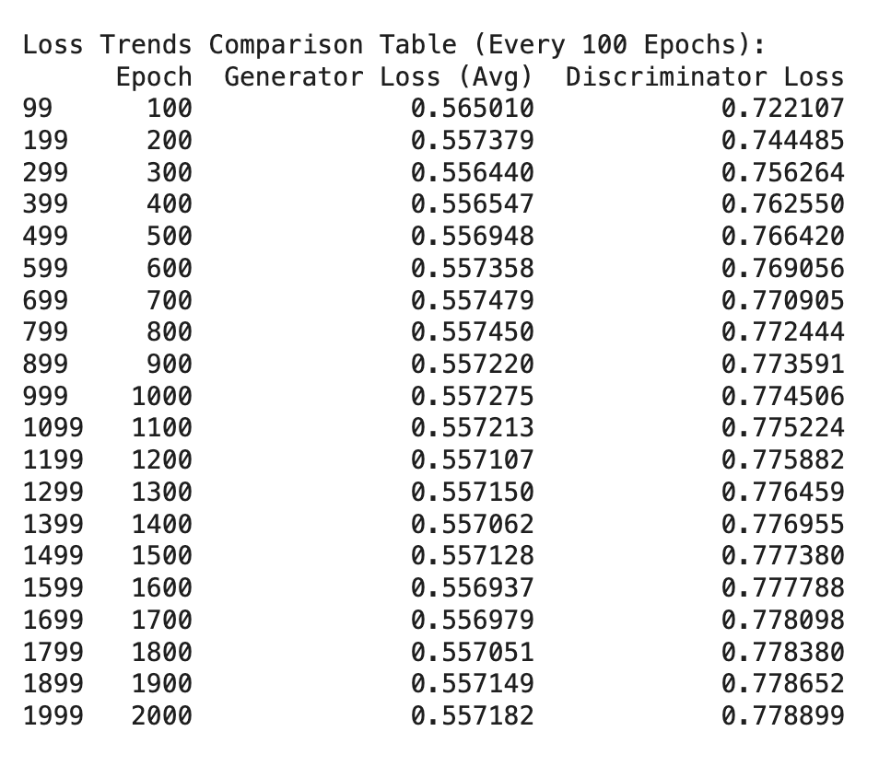**GAN-3:**

This model was better than the two above, as we can see that the loss of the generator has decreased over time, which means that the generator is improving in creating realistic data close to the real, and also, we can see that the discriminator is improving over time.

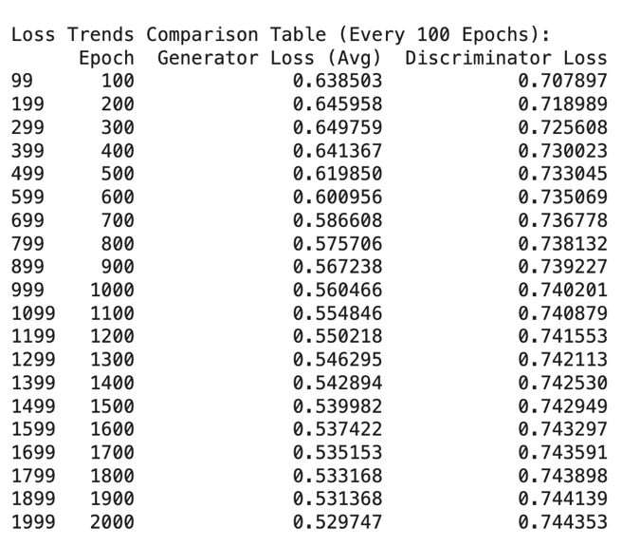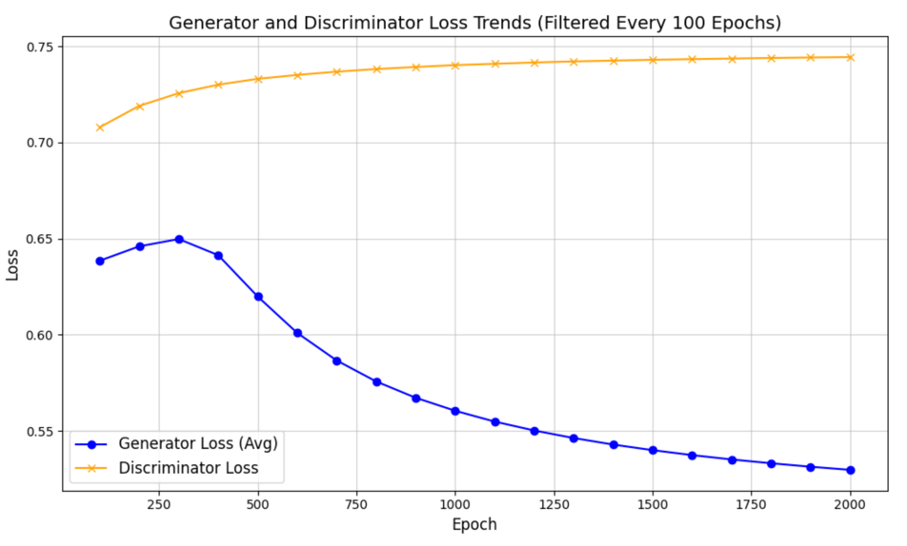**GAN-4:**

This model was the best one of all the models that I have made, as you can see that the generator loss has decreased a lot, which means it has learned too much from the discriminator feedback and was able to generate very close data to the real, and also the discriminator was improved a lot in classifying the classes and as we can see that the generator and the discriminator have achieved the level of balance.

## **Synthetic Data Evaluation**

Compare the distributions of synthetic or real data using statistical metrics (e.g., mean, variance) or visualizations (e.g., histograms, box plots).

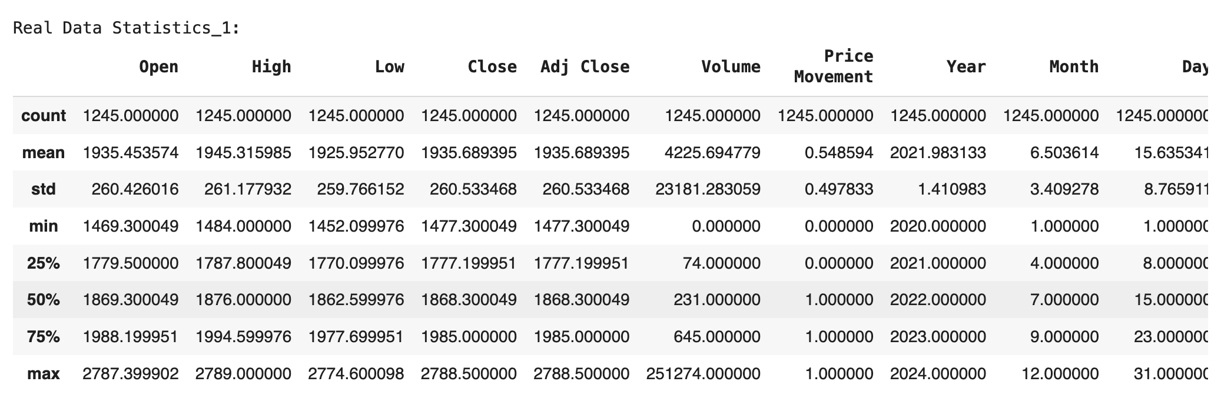**GAN-1 (Worst Model):**

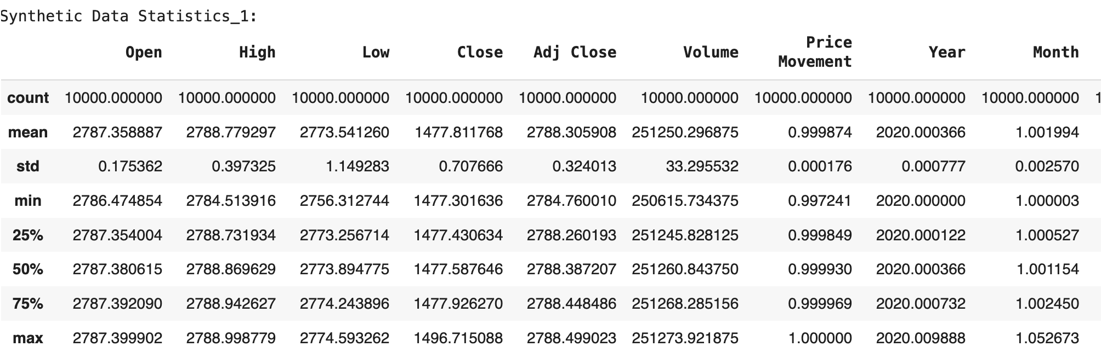

As we can see, this GAN model was very bad at making synthetic data; the generated data was very far from the real data. we can prove this just by tracking the mean of each feature, and also by tracking the quartiles of each feature; we can see that the generator does not catch the distribution of the values of each feature (all the values of the generated data was around fixed values). This GAN model needs a lot of improvements

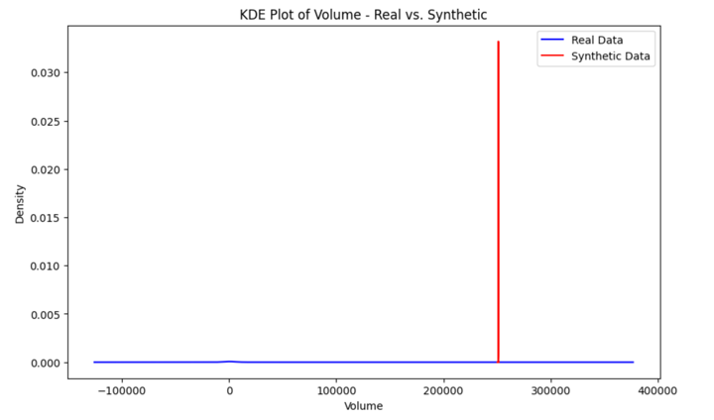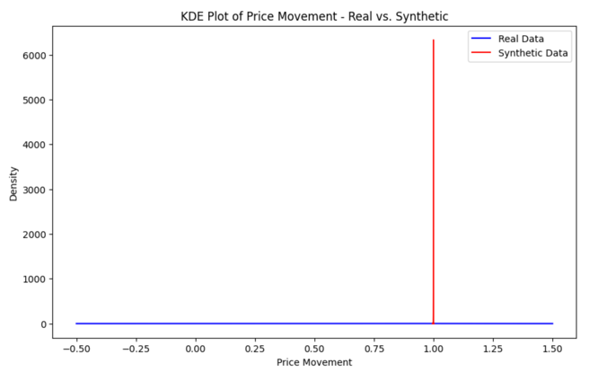

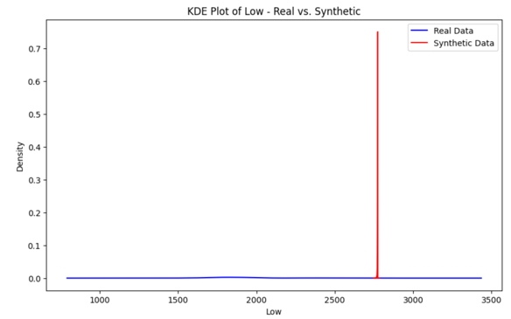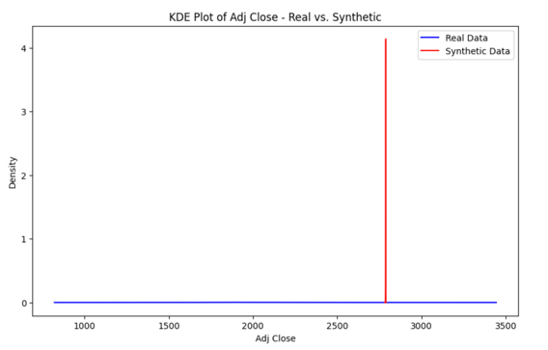

**GAN-4 (Best Model):**

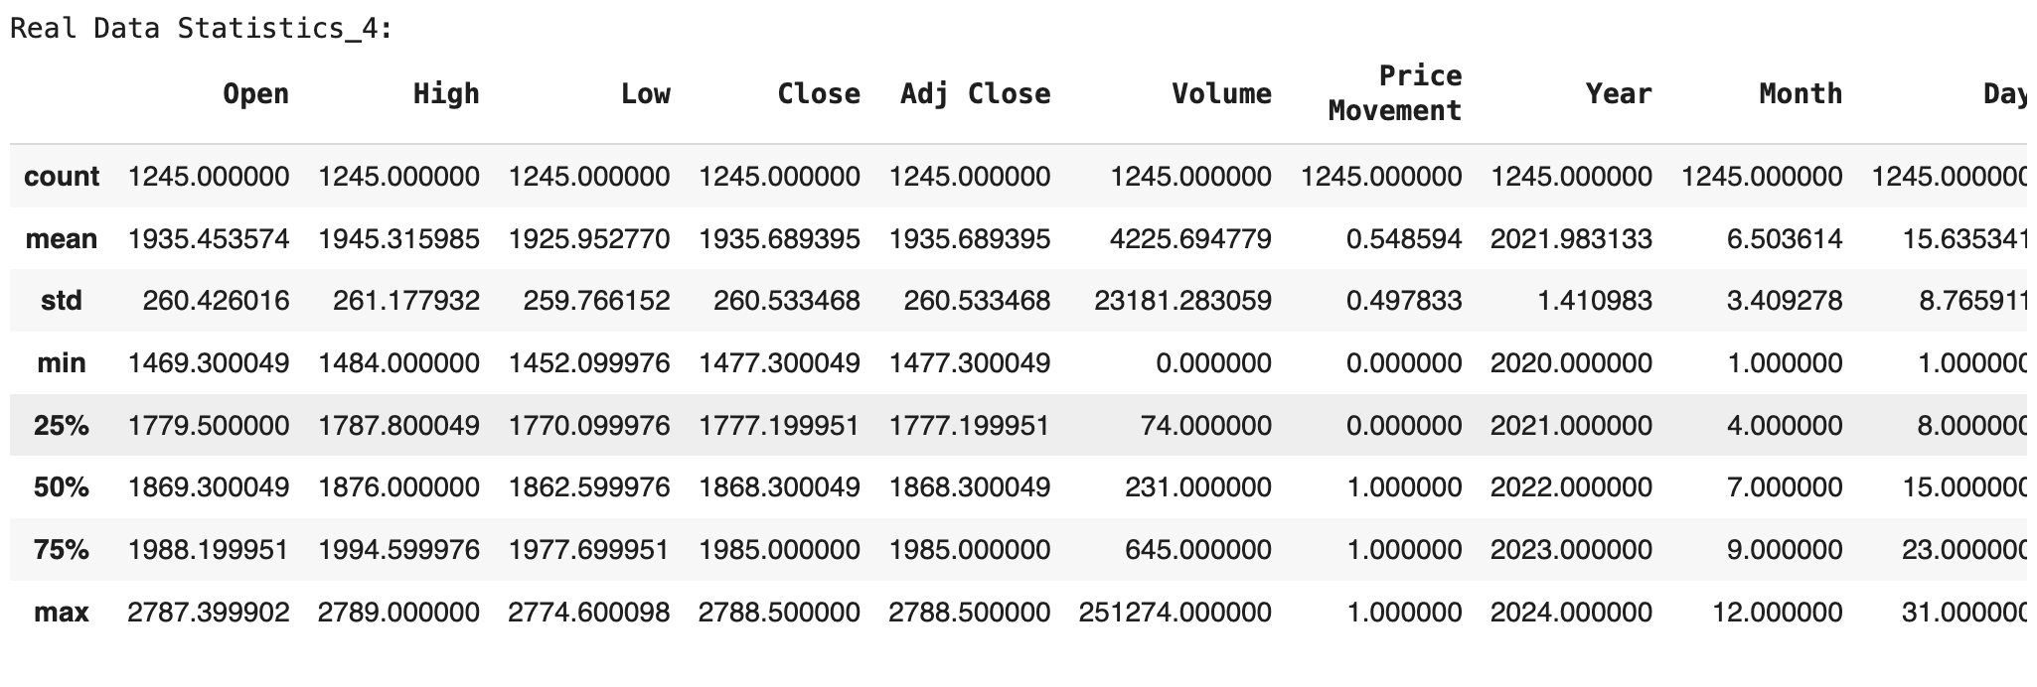

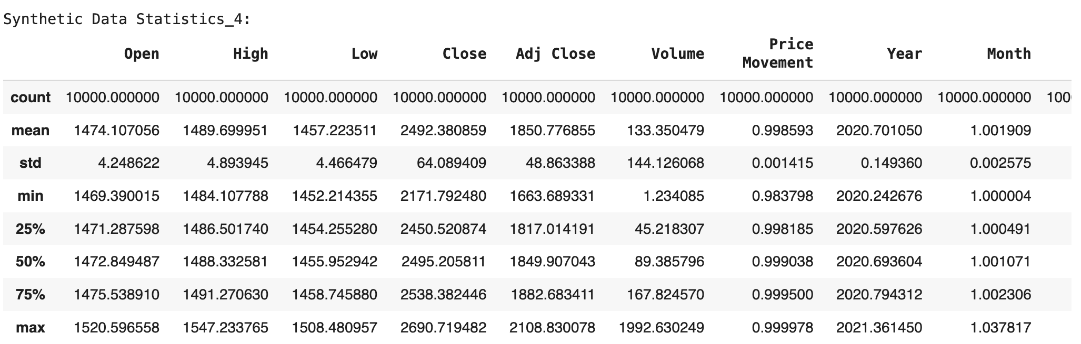

As we can see, this model has performed the best among all the GAN models that I have done, but even this, the model is very bad at generating synthetic data, and the generated data was very far from the real data we can prove this also from the quartiles and from the mean of each feature. Also, we can prove that the generator does not catch the distribution of the real data, as we can see down in the KDE plots.

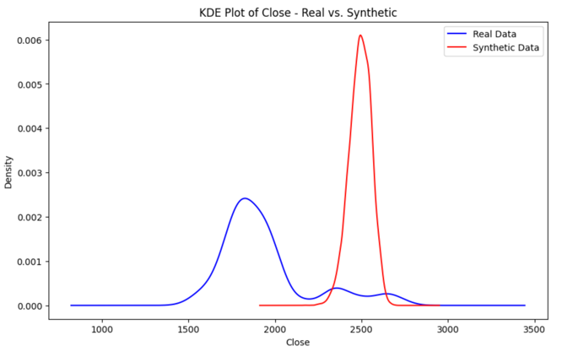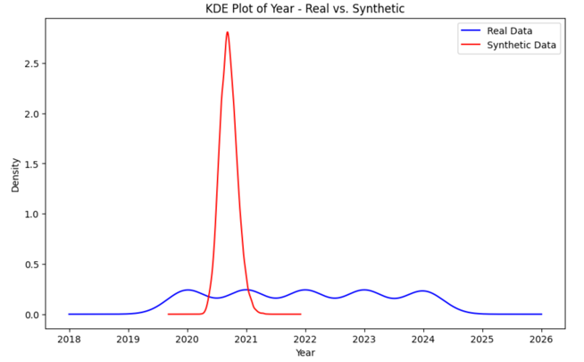

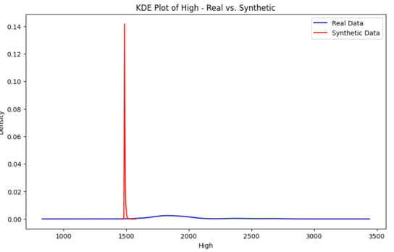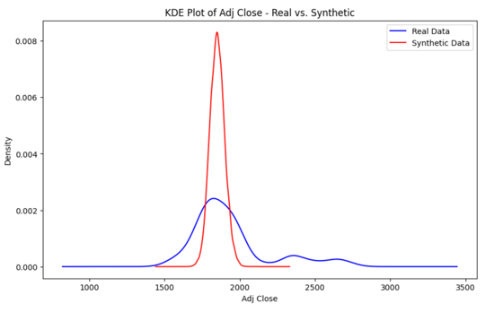

# **Fuzzy Inference System (FIS)**

## **System Description**

Describe the FIS, including inputs, outputs, and fuzzy rules.

I have done a Fuzzy Inference system; this system was designed to analyze the market condition if it is Bearish, Neutral, or Bullish based on the Trading Volume and Price Movement features.

**System Inputs:**

1. **Trading volume:** As a main step in doing the Fuzzy System, we have to do a membership function for each input and output, so before I did the triangle membership function for the volume, I checked the minimum and the maximum values of the volume, and also I had calculated the quartiles of this feature, the all this was made so I can know the range of the triangle membership function. but based on the values of the quartiles, I found that the Q3 of this feature is too far from the Max Value. I realized that there might be a lot of outliers, which might make my membership function not that accurate, but to double check, I plotted the distribution of the volume feature, and there were a lot of outliers as I expected, which made me change the max range of the membership function to have an accurate one.

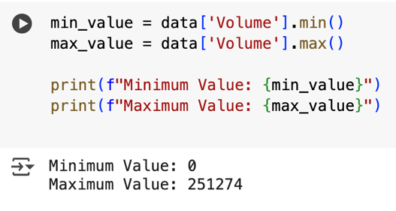

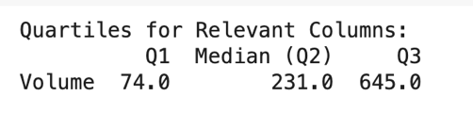

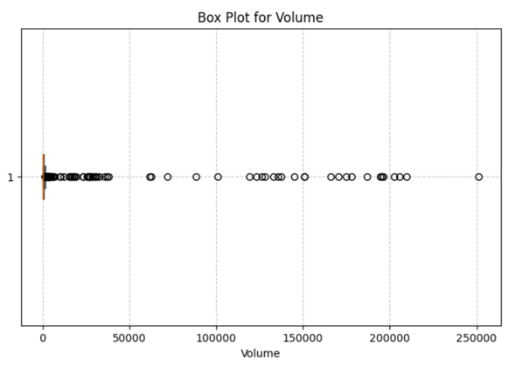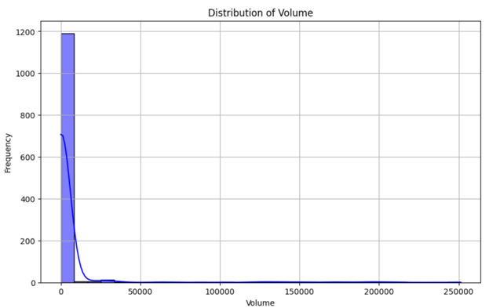

After this, I divided the Volume feature into three stages: the first one was Low Volume, the second one was Medium Volume, and the third one was High volume:

The starting point of the Low volume was the minimum value of the volume feature, the peak value of the Low Volume was the first quartile of the volume feature, and the ending point of the Low Volume was the Quartile two of the volume feature. ( 0, 74, 231).

The starting point of the Medium Volume was the Q1 value of the volume feature, the peak value of the Medium Volume was the second quartile of the volume feature, and the ending point of the Medium Volume was the Quartile three of the volume feature. ( 74, 231, 645).

The starting point of the High volume was the Q2 value of the volume feature, the peak value of the High Volume was the Q3 quartile of the volume feature, and the ending point of the High Volume was not the end value of the volume feature, because everything after 2000 was outliers, so I have taken a close number to the Q3 ( 231, 645, 1383).

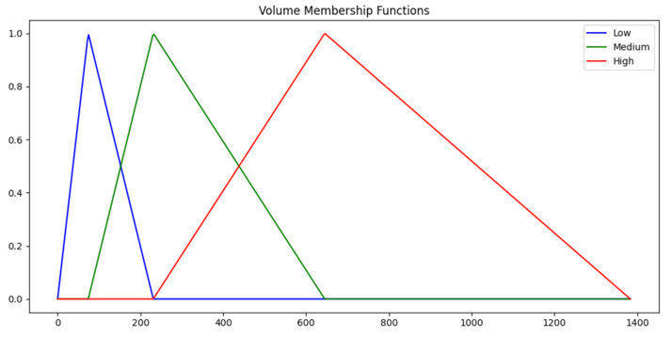

1. **Price movements:**

Since I want to do an accurate triangular membership function, and the price movement feature contains binary values, up or down, I decided to divide the up class into three classes, which are Low up, Medium up, and High up also, the down class divided into Low down, medium down, and high down, but it was very hard to do this but. I have found a very helpful founding, which is the way each class was classified, and I used this founding to make my membership function. The founding was that each class was classified based on this row’s Close value and the previous row’s Close value; if the current row’s Close value was bigger than the previous one, so the class was UP, but if the current row’s Close value was smaller than the previous row Close value it will be Down.

From here, I decided to make a new feature that calculates the distance between the current row’s Close value and the previous row’s Close value, and if the current row’s Close value is bigger than the previous make the distance value that was calculated Positive, but if the current row Close value is smaller than the previous make the distance value that was calculated Negative.

In this way, I was able to divide the up into levels and the down into levels based on the new feature that I have made, any negative value means its down and any positive value means its is up.

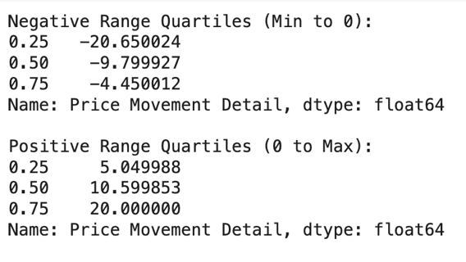I have found the minimum value of the new feature and the maximum value of the new feature, and also the quartiles from 0 to min and also from 0 to max so I can find the ranges of the triangular membership functions.

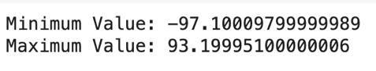

The Up class was divided into Low Up (0, 5.05, 10.6), Medium Up (5.05, 10.6, 20.0) and High Up (10.6, 20.0, 93.2).

And the Down class was divided into Low Down (-9.799927, -4.450012, 0), Medium Down (-20.650024, -9.799927, -4.450012) and High Down (-97.1, -20.650024, -9.799927).

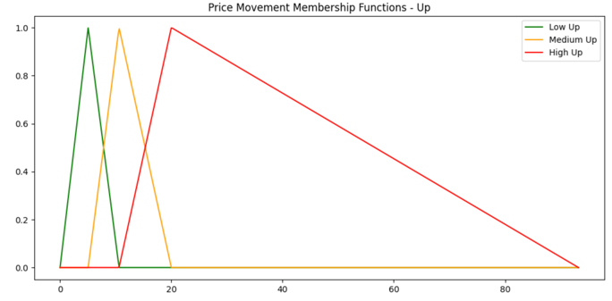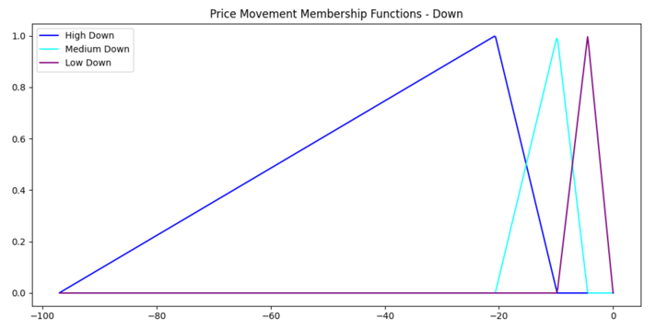

**System Output:**

**Market Condition:** This will be the output from the Fuzzy System, based on the rules that I will discuss after this part, I have used the triangular membership function to divide the Market Conditions into three levels: the first one Bearish, the second one Neutral, and the last one Bullish. The ranges of these three levels were defined based on the real-life logic.

The Bearish range was from (0, 25, 50)

The Neutral range was from (25, 50, 75)

The Bullish range was from (50, 75, 100)

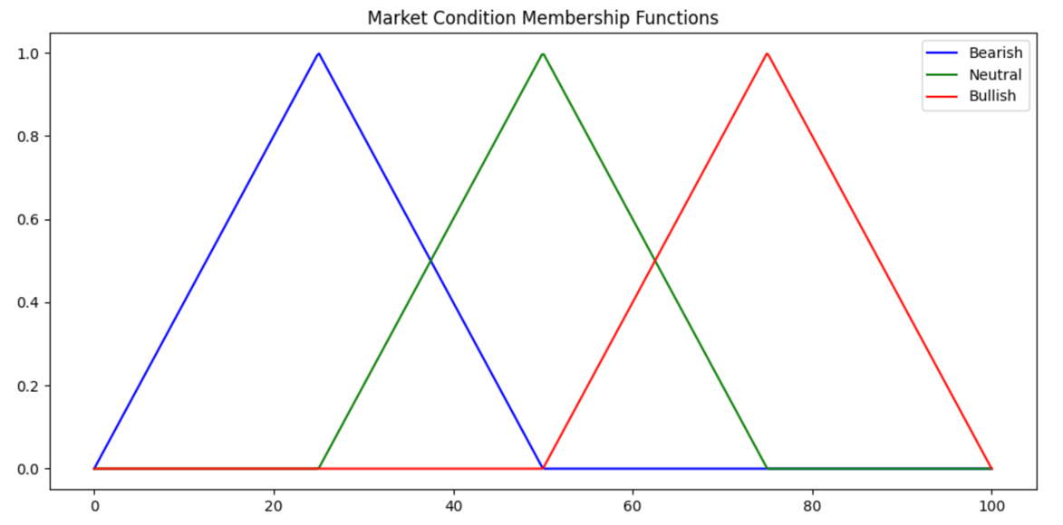

**Fuzzy System Rules:**

I have initialized 18 rules so I can cover all the expected inputs and I can get accurate results:

**The Bullish Rules (Market is Going Up):** A Bullish market condition period means that the price is expected to rise and might hit a new higher price, this condition usually happens when the volume is high. high volume means a lot of activity, and even when prices drop, they might recover quickly due to strong interest.

**Rule 1:** **(volume_high_level, movement_up_high):**

When both volume is high and price movement is strongly upward, this means that it is a signal for strong buying pressure, which is a classic bullish indicator. High volume confirms that many traders are participating.

**Rule 2: (volume_high_level, movement_up_medium):**

Even if the price increase is moderate, but also the volume is high, which suggests a positive sentiment. The market is likely in an uptrend which means it is a bullish condition.

**Rule 3: (volume_high_level, movement_up_low):**

Even the price movement is weakly positive, but also the high volume still indicates interest from buyers. The uptrend may be slower, but the market is still classified as bullish condition.

**Rule 4: np.fmin(volume_high_level, movement_down_high):**

High volume during a drop can be a sign of saving strength before an uptrend rise.

**Rule 5: (volume_high_level, movement_down_medium):**

The price is falling, but a lot of people are still trading. This suggests the market might turn around soon.

**Rule 6: (volume_high_level, movement_down_low):**

A slight decrease in price with lots of trading could mean buyers are still interested and might push prices back up.

**Neutral Rules:**

**Rule 13:** **(volume_medium_level, movement_down_high):**

The price is falling fast, but some people are still trading. It’s unclear if the drop will continue or stabilize.

**Rule 14: (volume_medium_level, movement_down_medium):**

Some selling is happening, but it’s not too strong. The market could go either way.

**Rule 15: (volume_medium_level, movement_down_low):**

The price is slowly moving, and trading isn’t too high. No clear trend.

**Rule 16: (volume_low_level, movement_up_high):**

The price is rising, but very few people are buying. This increase is weak and might not last.

**Rule 17: (volume_low_level, movement_up_medium):**

Price is rising a little, but since few people are buying, it’s not a strong trend.

**Rule 18: (volume_low_level, movement_up_low):**

Almost no movement and little trading. No clear trend, so it’s neutral.

**Bearish Rules (Expecting Prices to Go Down):** when prices go up but not many people are buying, the rise isn’t strong and might reverse. Also, when prices are dropping without buyers stepping in, the market keeps falling.

**Rule 7: (volume_medium_level, movement_up_high):**

Some buying is happening, but not enough to support the big jump in price. The rise might not last.

**Rule 8: (volume_medium_level, movement_up_medium):**

The price is going up, but not many people are buying. This could mean the increase is weak.

**Rule 9: (volume_medium_level, movement_up_low):**

The price is barely moving up, and not many people are trading. This usually means the market is weak and could drop soon.

**Rule 10: (volume_low_level, movement_down_high):**

Not many people are trading, but the price is crashing. This is a clear sign of trouble buyers are staying away.

**Rule 11: (volume_low_level, movement_down_medium):**

Price is falling, and there aren’t enough buyers to stop it. Likely to continue downward.

**Rule 12: (volume_low_level, movement_down_low):**

The market is quiet, and prices are slowly dropping. Without buyers, things could keep falling.

## **Sample Analysis**

Present defuzzified outputs for sample inputs from the dataset. Explain how these outputs were obtained and interpret the result

The input sample was Volume (107), and the Price Movement was (24)

So based on the triangular membership functions of the volume, the volume value is related to the range of the Low and also to the Medium-volume

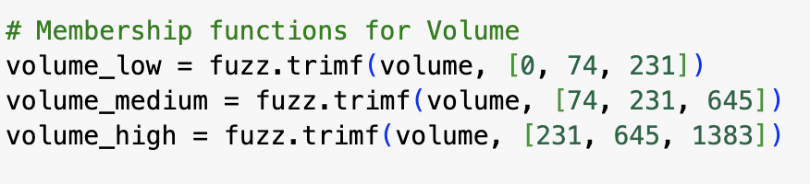

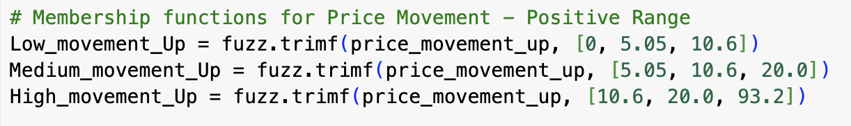Based on the triangular membership function of the price movement, since the input sample is positive, it relates to the up membership function based on the range this input value relates to high up.

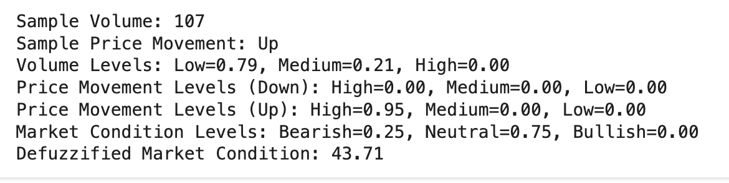**The outputs:**

After running the system, the fuzzy told me that the volume is 0.79 Low and 0.21 Medium based on calculating the membership function.

And also told me that the price movement is 0.95 high up.

Based on the rules it gave me, that it is 0.25 Bearish and 0.75 neutral.

This output was based on rule number 16 (volume_low_level, movement_up_high), which means it is Neutral.

Also, the defuzzied market condition value of 43.71 shows that it is neutral because when the value of defuzzied market condition is around 50 means it is neutral.

## **Visualizations**

Include: Input/Output membership function plots and Fuzzy rule surfaces.

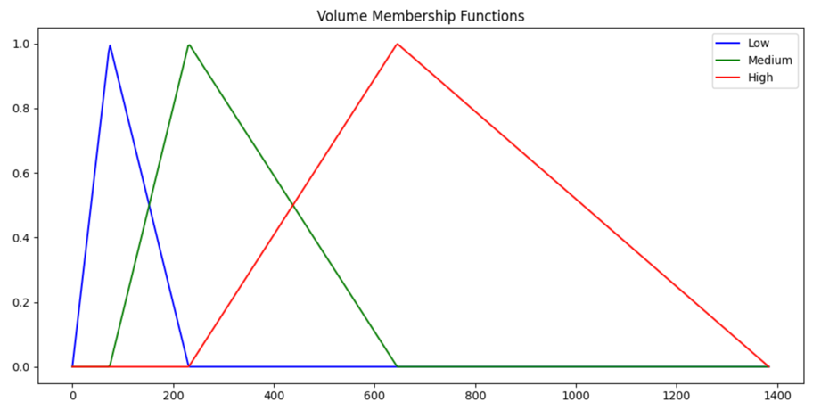**Input membership functions:**

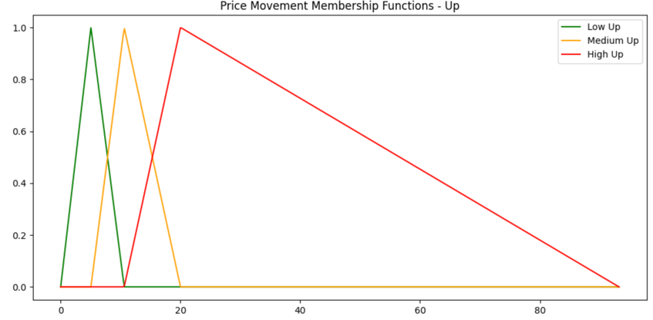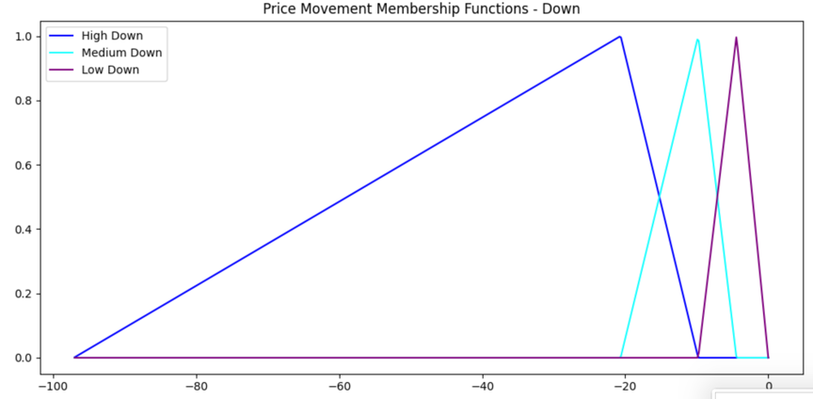

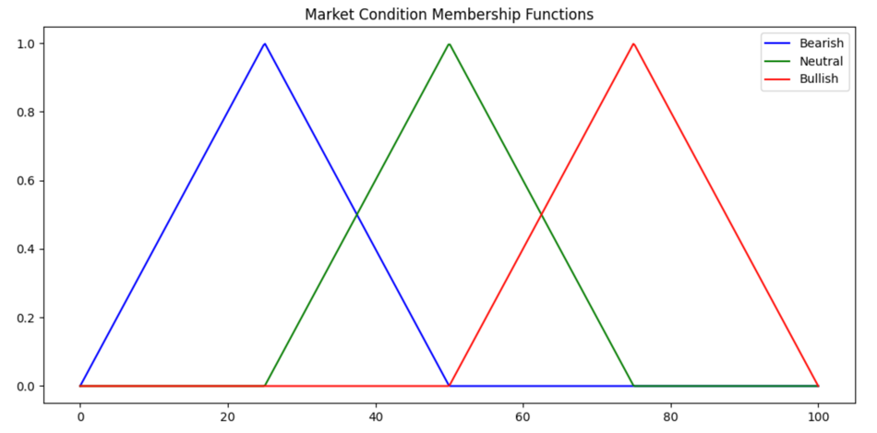 **Output membership functions:**

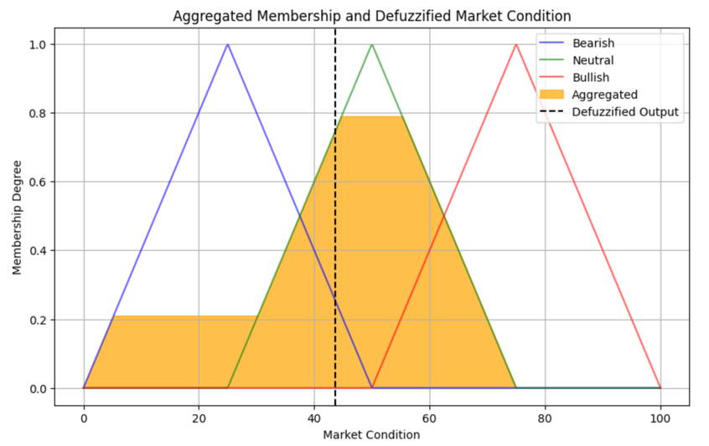

# **Advanced Fuzzy Logic System**

## **System Statement**

Provide a clear statement outlining the purpose and goals of your system.

This system was made using fuzzy logic to deduce the level of financial risk based on three key inputs, including high price, low price, and trading volume. Which this help to know and classify risk levels (Low, Medium, High) for financial instruments by analyzing the interplay of high prices, low prices, and trading volume.

## **System Design**

Define the inputs (e.g., High Price, Low Price, Volume) and output (Risk Level: Low, Medium, High). Describe the fuzzy rules used to map inputs to outputs

**System Input:**

1. **High Price:** I have defined the high price feature by using the triangular membership function and deviding it to High Low, High Medium, and High High. The ranges was defind by calculating the minimum value and the maximum value of the High feature and also by calculation the quartiles of the feature

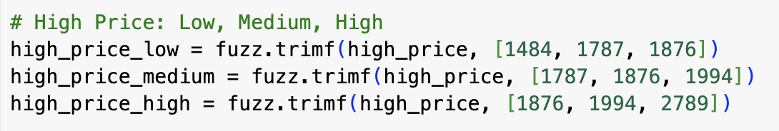

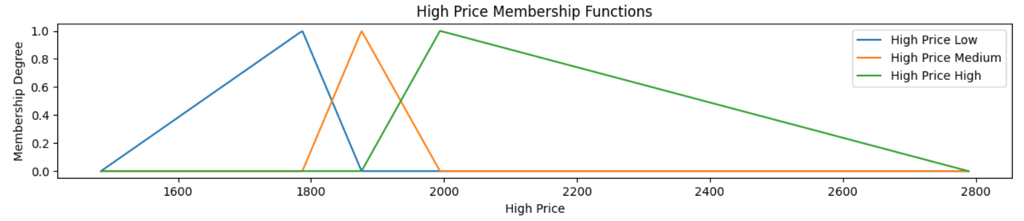

1. 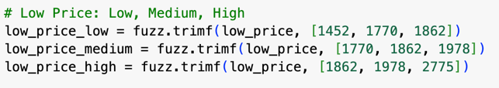**Low price:** I have defined the Low price feature by using the triangular membership function and dividing it to Low Low, Low Medium, and Low High. The ranges was defind by calculating the minimum value and the maximum value of the Low feature and also by calculation the quartiles of the feature.

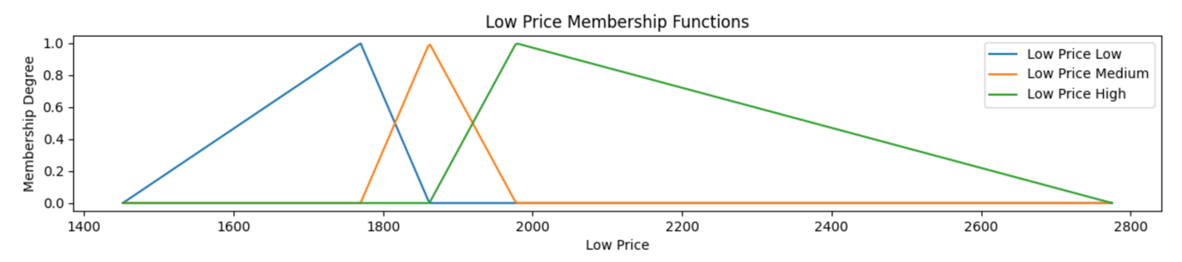

1. **Trading volume:** As a main step in doing the Fuzzy System, we have to do a membership function for each input and output, so before I did the triangle membership function for the volume, I checked the minimum and the maximum values of the volume, and also I had calculated the quartiles of this feature, the all this was made so I can know the range of the triangle membership function. but based on the values of the quartiles, I found that the Q3 of this feature is too far from the Max Value. I realized that there might be a lot of outliers, which might make my membership function not that accurate, but to double check, I plotted the distribution of the volume feature, and there were a lot of outliers as I expected, which made me change the max range of the membership function to have an accurate one.







After this, I divided the Volume feature into three stages: the first one was Low Volume, the second one was Medium Volume, and the third one was High volume:

The starting point of the Low volume was the minimum value of the volume feature, the peak value of the Low Volume was the first quartile of the volume feature, and the ending point of the Low Volume was the Quartile two of the volume feature. ( 0, 74, 231).

The starting point of the Medium Volume was the Q1 value of the volume feature, the peak value of the Medium Volume was the second quartile of the volume feature, and the ending point of the Medium Volume was the Quartile three of the volume feature. ( 74, 231, 645).

The starting point of the High volume was the Q2 value of the volume feature, the peak value of the High Volume was the Q3 quartile of the volume feature, and the ending point of the High Volume was not the end value of the volume feature, because everything after 2000 was outliers, so I have taken a close number to the Q3 ( 231, 645, 1383).



**System Output:**

**Risk level:** This will be the output from the Fuzzy System, based on the rules that I will discuss after this part, I have used the triangular membership function to divide the Risk Level into three levels: the first one Low risk, the second one Medium risk, and the last one High risk. The ranges of these three levels were defined based on the real-life logic.

The Low Risk range was from (0, 25, 50)

The Medium Risk range was from (25, 50, 75)

The High risk range was from (50, 75, 100)

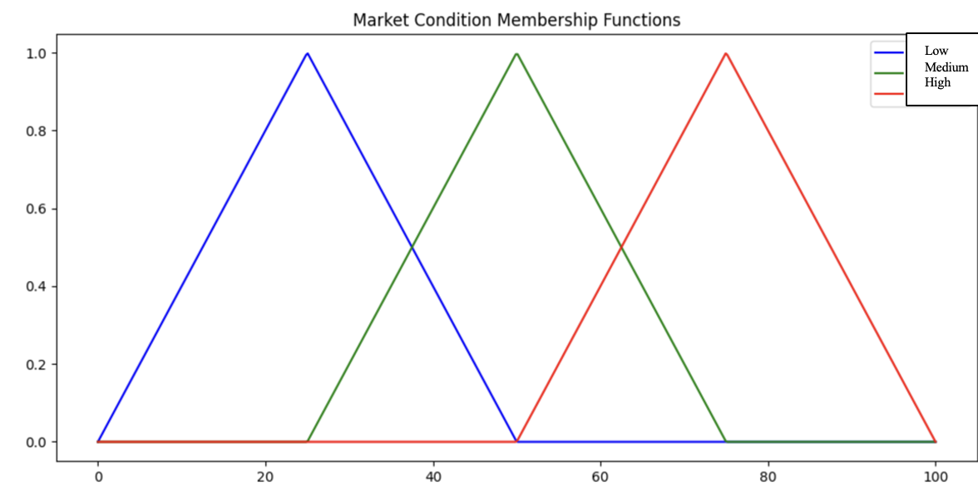

Fuzzy Rules:

1. **Low Risk**
   1. **Rule 1:** High Price = Low, Low Price = Low, Volume = Low  
      All inputs are low, indicating minimal risk.
   2. **Rule 2:** High Price = Low, Low Price = Low, Volume = Moderate  
      Moderate volume with low prices still keeps risk low.
   3. **Rule 4:** High Price = Low, Low Price = Medium, Volume = Low  
      Moderate low prices and low volume indicate low risk.
   4. **Rule 7:** High Price = Low, Low Price = High, Volume = Low  
      High low prices, but low volume mitigates risk.
   5. **Rule 10:** High Price = Medium, Low Price = Low, Volume = Low  
      Low prices and low volume result in low risk.
   6. **Rule 13:** High Price = Medium, Low Price = Medium, Volume = Low  
      Balanced prices and low volume indicate low risk.
   7. **Rule 16:** High Price = Medium, Low Price = High, Volume = Low  
      High low prices, but low volume keeps the risk low.
   8. **Rule 19:** High Price = High, Low Price = Low, Volume = Low  
      Low volume mitigates risk despite high prices.
   9. **Rule 22:** High Price = High, Low Price = Medium, Volume = Low  
      Low volume offsets high prices to keep risk low.
   10. **Rule 25:** High Price = High, Low Price = High, Volume = Low  
       High prices, but low volume keeps the risk low.

**Medium Risk**

**Rule 3:** High Price = Low, Low Price = Low, Volume = High

**Why:** High volume with low prices indicates increased market activity, raising the risk to a moderate level.

**Rule 5:** High Price = Low, Low Price = Medium, Volume = Moderate

**hy:** Moderate low prices and moderate volume suggest noticeable market activity, leading to medium risk.

**Rule 8:** High Price = Low, Low Price = High, Volume = Moderate

**Why:** Moderate volume with high low prices increases market uncertainty, resulting in medium risk.

**Rule 11:** High Price = Medium, Low Price = Low, Volume = Moderate

**Why:** Moderate volume and medium high prices increase market activity, leading to medium risk.

**Rule 14:** High Price = Medium, Low Price = Medium, Volume = Moderate

**Why:** All inputs at moderate levels suggest a balanced but active market, resulting in medium risk.

**Rule 17:** High Price = Medium, Low Price = High, Volume = Moderate

**Why:** High low prices combined with moderate volume create market fluctuations, leading to medium risk.

**Rule 20:** High Price = High, Low Price = Low, Volume = Moderate

**Why:** High prices with moderate volume indicate an active market, raising the risk to medium.

**Rule 23:** High Price = High, Low Price = Medium, Volume = Moderate

**Why:** High prices with moderate prices and volume result in increased market activity, creating medium risk.

**Rule 26:** High Price = High, Low Price = High, Volume = Moderate

**Why:** High prices and moderate volume lead to potential market fluctuations, resulting in medium risk.

**High Risk**

**Rule 6:** High Price = Low, Low Price = Medium, Volume = High

**Why:** High volume with moderate prices signals significant market activity, creating high risk.

**Rule 9:** High Price = Low, Low Price = High, Volume = High

**Why:** High volume and high low prices indicate substantial market movement and volatility, resulting in high risk.

**Rule 12:** High Price = Medium, Low Price = Low, Volume = High

**Why:** High volume with medium high prices increases market activity, leading to high risk.

**Rule 15:** High Price = Medium, Low Price = Medium, Volume = High

**Why:** High volume across balanced prices creates intense market movement, resulting in high risk.

**Rule 18:** High Price = Medium, Low Price = High, Volume = High

**Why:** High prices, high low prices, and high volume lead to maximum volatility, creating high risk.

**Rule 21:** High Price = High, Low Price = Low, Volume = High

**Why:** High prices combined with high volume suggest extreme market activity, resulting in high risk.

**Rule 24:** High Price = High, Low Price = Medium, Volume = High

**Why:** High prices, moderate low prices, and high volume increase market volatility, leading to high risk.

**Rule 27:** High Price = High, Low Price = High, Volume = High

**Why:** All inputs are at high levels, reflecting maximum market uncertainty and volatility, resulting in the highest risk.

## **System Validation**

Discuss the validation results using dataset examples.

The input sample was high_price (1777), and the low_price was (1500), and Volume was (900)

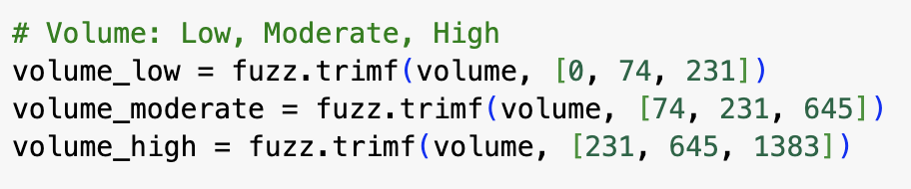So based on the triangular membership functions of the volume, the volume value is related to the range of the High

Based on the triangular membership function of the high_price, it relates to low High range.

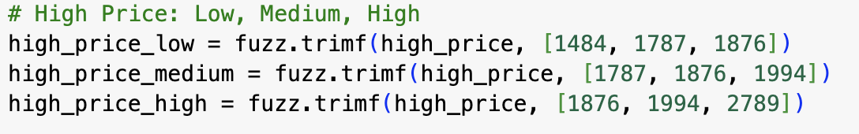

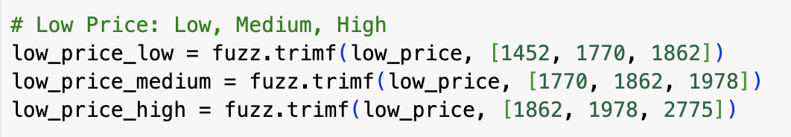Based on the triangular membership function of the low_price it relates to low Low range.

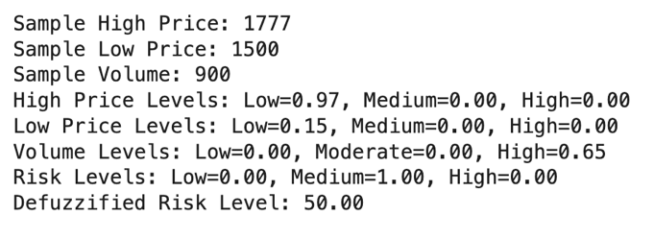**The outputs:**

After running the system, the fuzzy told me that the volume is 0.65 High based on calculating the membership function.

And also told me that the High Price is 0.97 Low.

Also have me that the Low Price is 0.15 Low.

Based on the rules it gave me, that this smaple 1.00 Medium Risk.

This output was based on rule number 3 (Low, Low Price = Low, Volume = High), which means it is Medium Risk.

Also, the defuzzied market condition value of 50.00 shows that it is Medium risk because when the value of defuzzied market condition is 50 or around 50 means it is Medium Risk.

## **Visualizations**

Include: Membership function plots, Fuzzy rule visualizations, and Surface plots illustrating the relationship between inputs and the Risk Level output





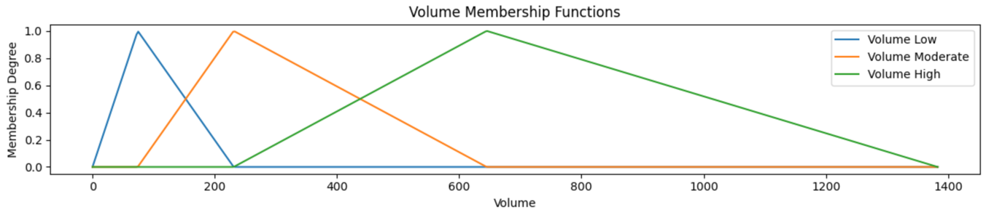

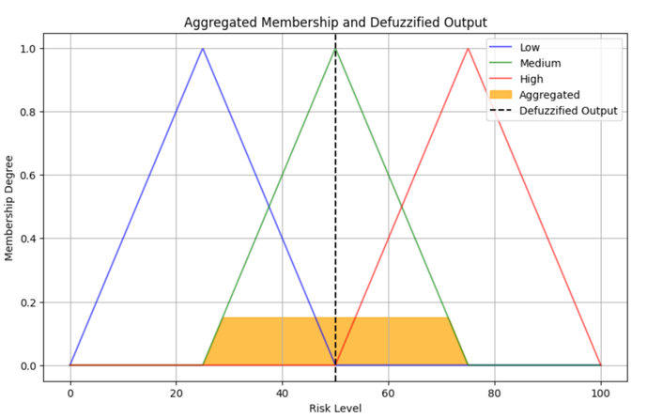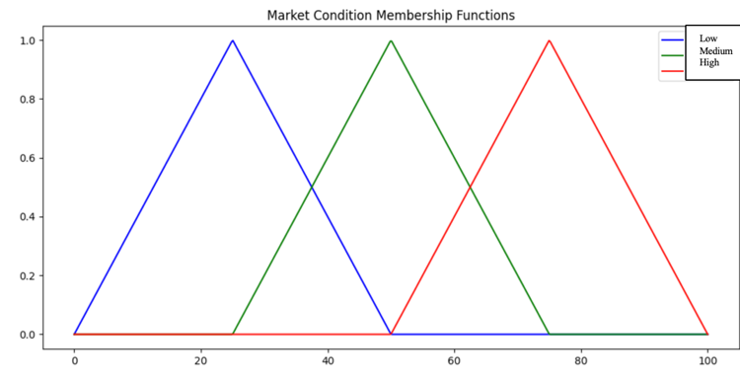

# **XAI Framework for Price Movement Prediction**

## **Predictive Models**

Provide a summary table of initial performance metrics (e.g., accuracy) for two machine learning models used to predict "Price Movement".

|  |  |  |
| --- | --- | --- |
| **Models** | **Random Forest Classifier** | **Decision Tree Classifier** |
| **Accuracy** | 0.96 | 0.67 |

As you can see I have used two deferent machine learning classifications models: the first one was Random Forest Classifier and the second one was Decision Treen Classifier. The Random Forest model has gave me better accuracy in predicting the Price Movement feature.

## **SHAP Analysis**

Explain specific predictions using SHAP. Include:

* Analysis of SHAP values for key features

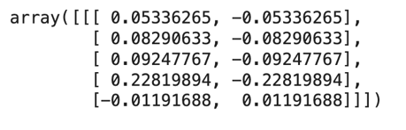

**Sample One: Random Forest Model (Down):**

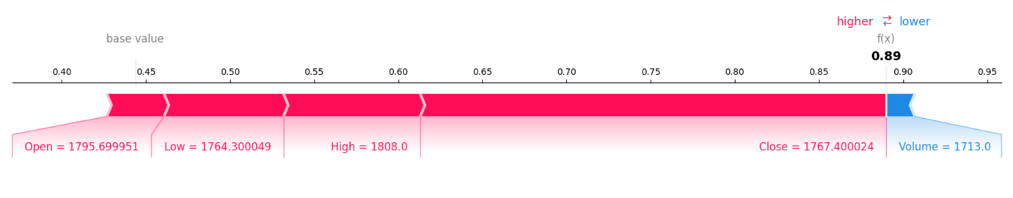

The base value of the model is about 0.45, which is the average prediction before considering any feature impacts. The SHAP below shows how features like Open (1795.699951), Low (1764.300049), High (1808.0), Close (1767.400024), and Volume (1713.0) have driven the final prediction of 0.89. Features that positively push the prediction higher are colored in red, while those with a negative influence, pulling the prediction lower, are colored in blue. Among the features, Close price is the most important feature to the prediction, adding 0.228 to the prediction. Other features like High, Low, and Open also have positive contributions with relatively smaller magnitudes, respectively. While on the other side, Volume slightly reduces the prediction. Due to symmetry, the SHAP values bring balance-both for positive and negative contributions for each feature-and their cumulative sum explains how the base value was adjusted in order to result in the final prediction.

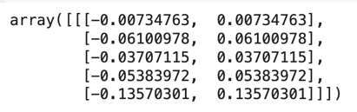**Sample Two: Random Forest Model (UP):**

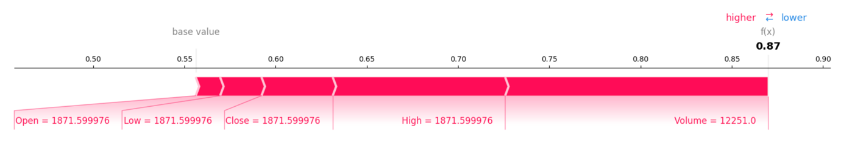

The base value, being the average model output before taking into account feature contributions, is approximately 0.55. The base value here is adjusted by the features Open (1871.599976), Low (1871.599976), Close (1871.599976), High (1871.599976), and Volume (12251.0) to arrive at the final prediction. Among these, the feature Volume has the most value with a positive contribution and hence is the key driver of the prediction. While Low, Close, and High contribute positively correspondingly the contribution of the feature Open is practically zero, at. Here, for this example, SHAP values are symmetric, in the sense that for each feature, positive and negative contributions balance with respect to explanation of how model comes to the decision. The aggregated effect of these feature contributions is to raise the base value prediction to the final output of 0.87, reinforcing that in this example, the dominant feature was indeed Volume.

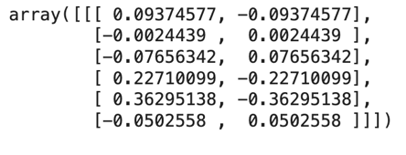**Sample One: Decision Treen Model (Down):**

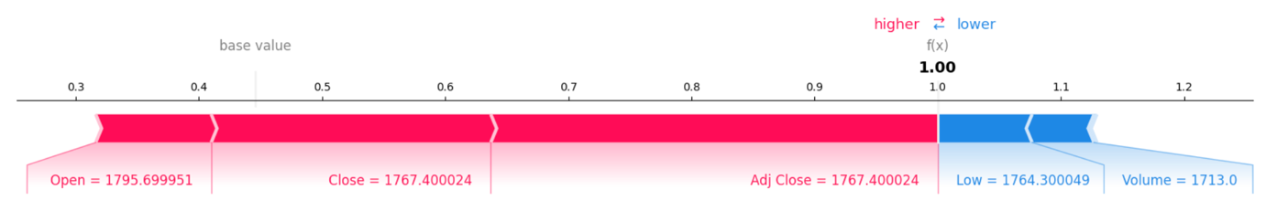

This would give an estimate of approximately 0.40, the average prediction if no features were used to make the forecast. In making this final prediction, features of Open: 1795.699951, Close: 1767.400024, Adj Close: 1767.400024, Low: 1764.300049, and Volume: 1713.0 are added onto this base. Of these, the highest positive contribution by any single feature for the forecast comes from Adj Close, which makes it the most influential feature of prediction. Positive contributions come from the features Open and Close , respectively. In contrast, the Low and Volume features have a negative impact on the prediction, pulling it slightly downward and respectively. Symmetry in SHAP values ensures that for every feature, there are positive and negative contributions, making the model's decision transparent and balanced at the same time. Therefore, each of these added contributions finally grows this base value, 0.40, up into the final prediction of 1.00 because the feature makes this particular prediction most related to Adj Close.

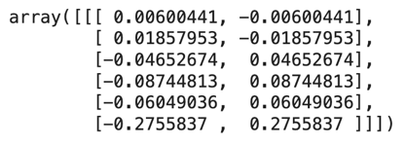**Sample Two: Decision Treen Model (UP):**

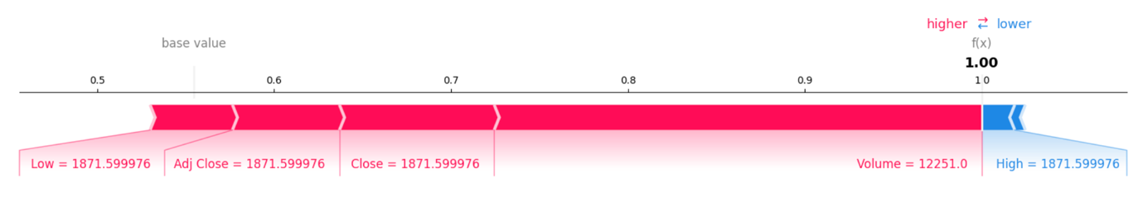

The base value, around 0.50, shows the average prediction before accounting for individual feature contributions. Low features, such as 1871.599976, Adj Close at 1871.599976, Close at 1871.599976, Volume at 12251.0, and High at 1871.599976, cumulatively adjust the base value to make the final prediction. Of the mentioned features, Adj Close has the highest positive contribution, which is the most influential feature pushing the prediction upwards. The Low and Close also have positive features but with adjustments, respectively. This is while Volume and High have negative features, pulling the predictions down, respectively. Symmetry among the SHAP values ensures there is a balancing effect between positivity and negativity, leading to transparency of the model when making decisions. These contributions sum up to increase the base value of 0.50 to the final prediction of 1.00, showing Adj Close is dominant in this particular prediction.

* **SHAP summary plot showing overall feature importance:**

**Model-1(Random Forest):**

**Class 0 (Down):**

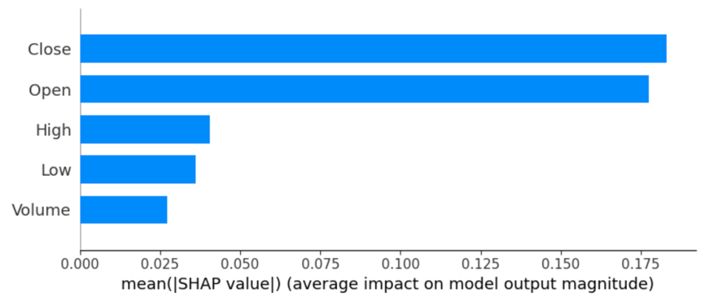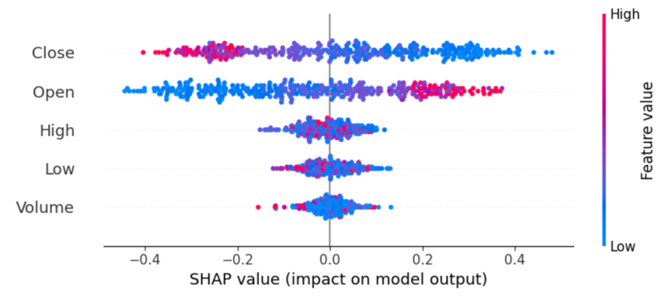

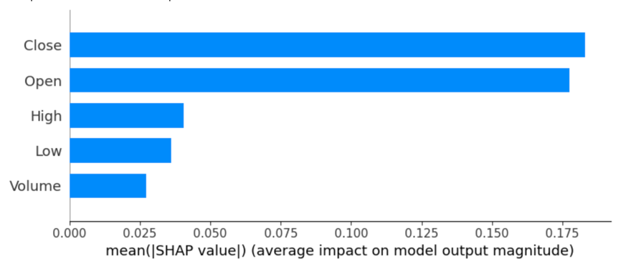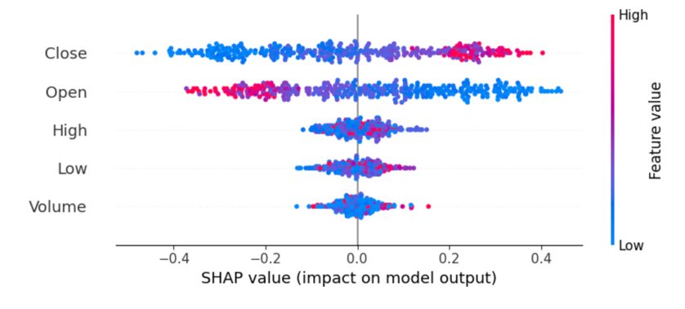 **Class 1 (UP):**

**Model-2 (Decision Tree):**

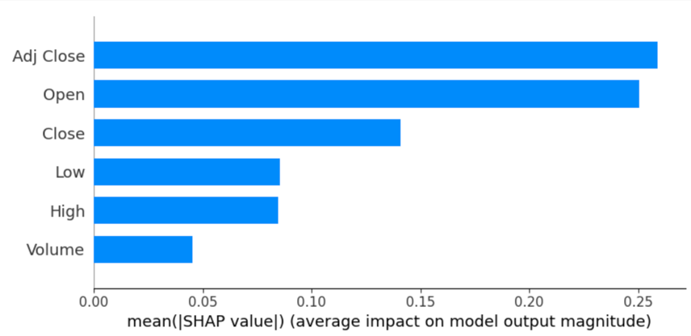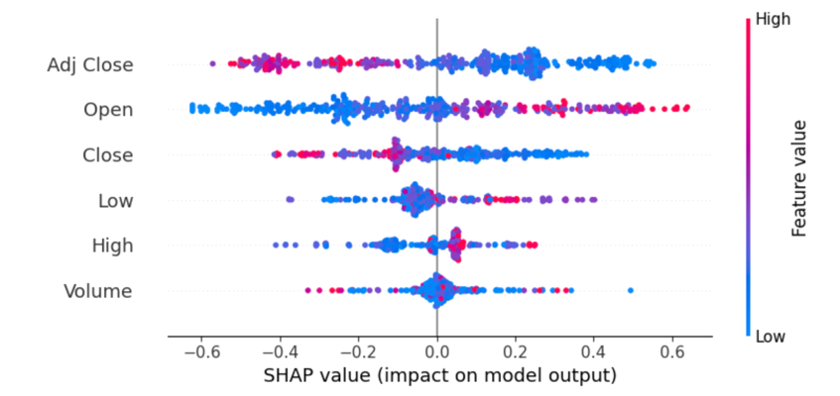 **Class 0 (Down):**

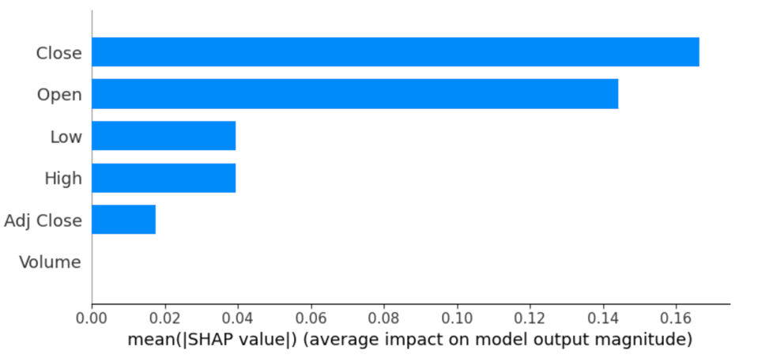 **Class 1 (UP):**

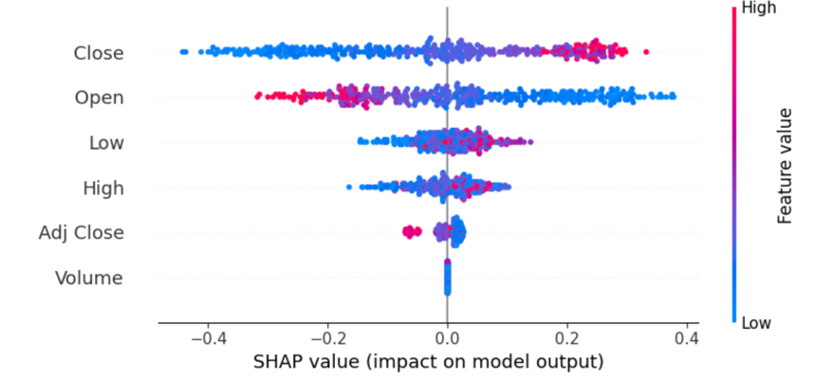

## **LIME Analysis**

Explain specific predictions using LIME. Include:

* Analysis of LIME values for key features

**Sample One: Random Forest Model (Down):**

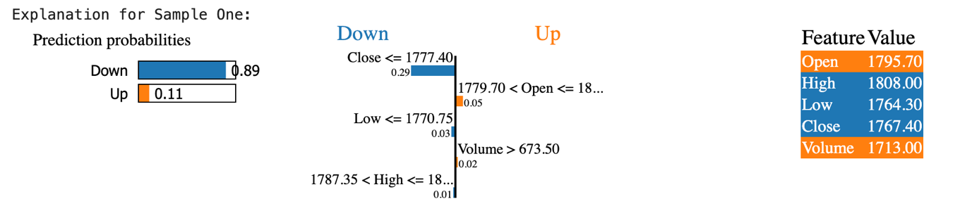

According to the model, the probabilities for "Down" and "Up", respectively. It shows the main characteristics that affect this prediction and how they influence both classes. The feature "Close" contributes the most to the "Down" class; hence, the "Down" prediction is highly supported when lower closing prices are considered. Open" and "Low" also contribute a small amount to the "Up" and "Down" predictions, respectively. The "High" feature has no effect on the overall prediction, while the "Volume" feature marginally favors the "Up" class with a contribution of 0.02. Feature values such as "Open = 1795.70" and "Close = 1767.40" provide context for these contributions.

**Sample Two: Random Forest (Up):**

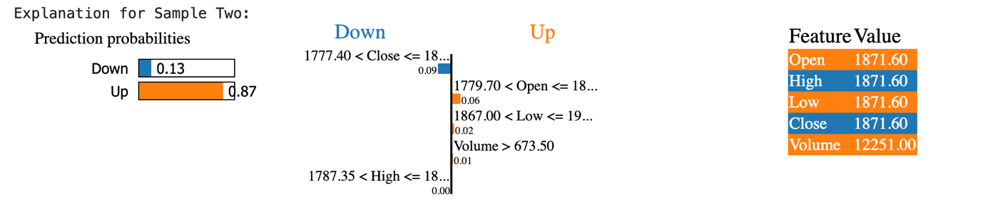

where the model predicts "Up" with 0.87 probabilities and "Down" with probabilities of 0.13. For "Up," the most important feature is "Close" with a strong positive contribution. A higher value for "Close" speaks in favor of class "Up". The contribution is followed by "Open", and supporting "Up", but this has a somewhat lower impact. The "Low" feature contributes a small positive to support the "Up" prediction, while the features "Volume" and "High" are with values close to 0, their contributions to the prediction being almost negligible. These feature values, such as "Open = 1871.60" and "Close = 1871.60," provide context for these contributions.

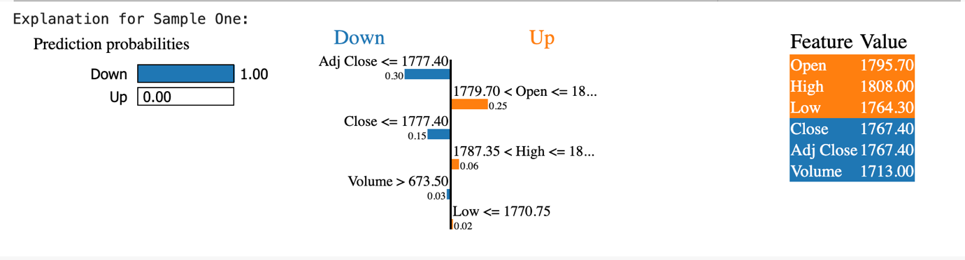**Sample One: Decision Tree Model (Down):**

The model's "Down" prediction with a probability of 1.00 and "Up" with a probability of 0.00. The key features driving "Down" predictions are "Adj Close," with the largest contribution, having a value of 0.30, thus showing that the lower the adjusted close value, the stronger this class is supported. Another feature that most contributes to "Down" prediction is "Close" . Other features are "Volume," which contributes marginally to the "Down" prediction. In the "Up" class, the "Open" feature contributes most, while "High" contributes a little. These contributions are not strong enough to counterbalance the strong indicators for "Down.". Feature values like "Open = 1795.70," "Adj Close = 1767.40" give context to these contributions as to why the strong contribution towards the "Down" class was done. This shows that the adjusted closing price and closing price are the most important drivers in the model's decision.

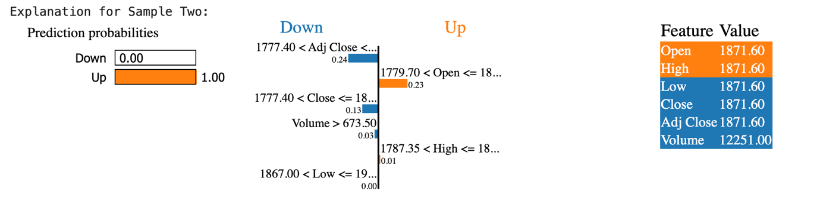**Sample Two: Decision Tree Model (Up):**

model's prediction of "Up," with a probability of 1.00 and "Down" with a probability of 0.00: Indeed, the most contributing features to the "Up" prediction are "Open," which has the most positive contribution, thereby strongly supporting the "Up" class. Moreover, "Adj Close" also serves as a feature that strongly indicates an upward stock price movement in the "Up" class with its positive contribution . On the other hand, "Close" contributes toward "Down" but with the low value, outnumbered by strong indications for "Up." Finally, "Volume" has a really low contribution in this case toward "Down," and "High" contributes almost negligibly to either class. The feature values, such as "Open = 1871.60" and "Volume = 12251.00," are the contexts of these contributions-that is, the reasons why the model strongly favors the class "Up." This analysis underlines how opening and adjusted closing prices have a great influence on the model confidence of the "Up" class prediction.

## **Comparison of SHAP and LIME**

Compare the insights provided by SHAP and LIME for the same predictions. Specifically, examine how each method identifies which features support or oppose a prediction decision

**Sample One: Random Forest Model (Down):**



SHAP is for global explanations since it shows how all the features combine interactively to move from the base value to get to that final prediction 0.89 in this case. SHAP identifies "Close" as the most important feature with a strong push toward increasing the prediction, while "Volume" is somewhat opposed to that. On the other hand, LIME gives a local explanation by breaking down feature contributions for specified class probabilities. It reveals "Close" as the biggest contributor to the "Down" class probability at 0.29 and "Open" as a minor supporter of the "Up" class. While SHAP is particularly good at showing overall feature impact, LIME is very focused on class-specific probabilities, so the two techniques are complementary when understanding predictions.

|  |  |  |  |  |  |
| --- | --- | --- | --- | --- | --- |
|  | **Close** | **Low** | **High** | **Volume** | **Open** |
| **Shap** | Down | Down | Down | Up | Down |
| **Lime** | Down | Down | Down | Up | Up |

**Sample Two: Random Forest (Up):**



SHAP and LIME are providing complementary explanations of the same prediction. In the SHAP plot, the forecast of 0.87 is portrayed as a consequence of cumulative feature contributions from the base value of 0.55, when the "Volume" characteristic contributed most positively to raise the prediction very high, though "Open" and "High" have less of an impact. SHAP provides the direction and magnitude of the contribution of each feature to the output; it explains how each feature is related to the result in general. While "Open" and "Low" drive the "Up" probability of 0.87, "Close" makes the biggest contribution to the "Down" probability of 0.13, LIME says, focusing on explaining class probabilities.

|  |  |  |  |  |  |
| --- | --- | --- | --- | --- | --- |
|  | **Close** | **Low** | **High** | **Volume** | **Open** |
| **Shap** | Up | Up | Up | Up | Up |
| **Lime** | Down | Up | Down | Up | Up |

**Sample One: Decision Tree Model (Down):**



SHAP explains the prediction by showing how the features cumulatively shift the base value of 0.4 toward the final output of 1.00. The most relevant strong contributing features include "Adj Close" and "Close". Therefore, from a certain aspect, opposing is being driven by the low "Low" and "Volume." Features give meaning to continuous outcome development on an accumulative basis according to SHAP. On the other hand, LIME breaks this down into class-specific probabilities and identifies "Adj Close" as the largest contributory factor towards "Down" with 0.30, followed by "Close" with 0.15. Opposing this, "Open" and "High" made minor contributions toward "Up" but could not withhold the strong support for "Down.".

|  |  |  |  |  |  |  |
| --- | --- | --- | --- | --- | --- | --- |
|  | **Close** | **Low** | **High** | **Volume** | **Open** | **Adj CLose** |
| **Shap** | Down | Up | Down | Up | Down | Down |
| **Lime** | Down | Up | Up | Down | Up | Down |

**Sample Two: Decision Tree Model (Up):**





As you can see that using Shap the base value was 0.5 but the features Low, ADJ Close, Close, and Volume was the reason to push the prediction to Up but the High feature was in the opposite way it was pushing to the down. But moving on to Lime the probability of the prediction was 1 which is UP but it is not like the Shap, the Adj Close, Close, Low, and volume bas pushing to down in small amounts but Open, and High features was pushing Up.

|  |  |  |  |  |  |
| --- | --- | --- | --- | --- | --- |
|  | **Close** | **Low** | **High** | **Volume** | **Open** |
| **Shap** | Up | Up | Down | Up | Up |
| **Lime** | Down | Down | Up | Down | Up |

# **Bias and Equity Evaluation**

## **Model Performance Analysis**

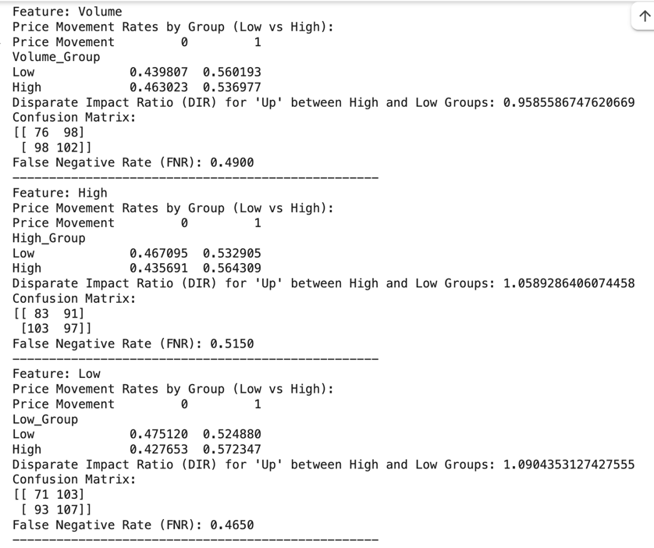Evaluation of model performance across different features.

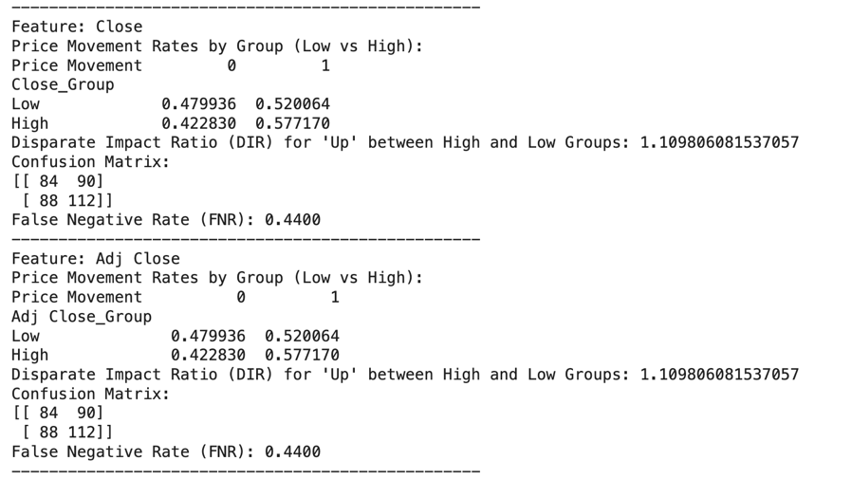

As evaluating we can see that all the features dose not show bias because all the values of DIR is under 1.2 and over 0.80 and this was shown when using the Random forest model with equalized bins using Quartiles that divide each feature to two groups High and low. The Techniques that was used in the DIR and CM does not show that there is a bias in the columns toward the classification of the price movement. All the feature DIR did not exed the 1.2 DIR and dose not goes under 0.8. it could be related to the model that I have used can handel the small bias that is in the data.

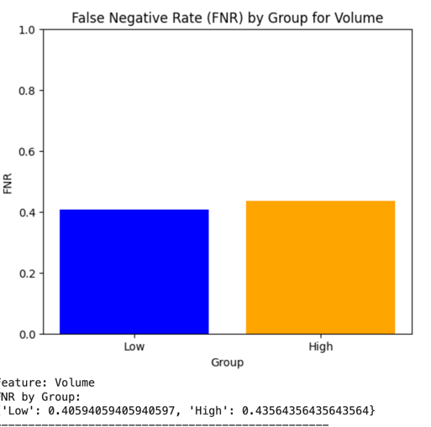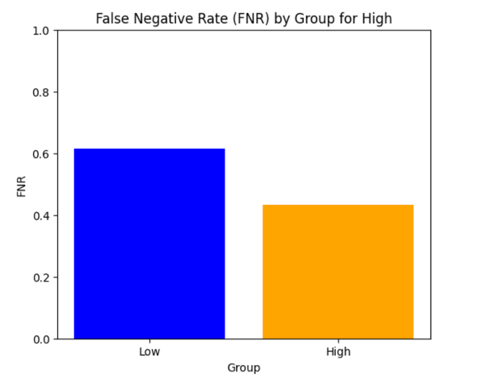But fot the FNR that I have used and calculate on all the feature it dose show bias based on what is wtitrn in the slides that if there is a deference between the FNR of the two groups that shows that there is a bias

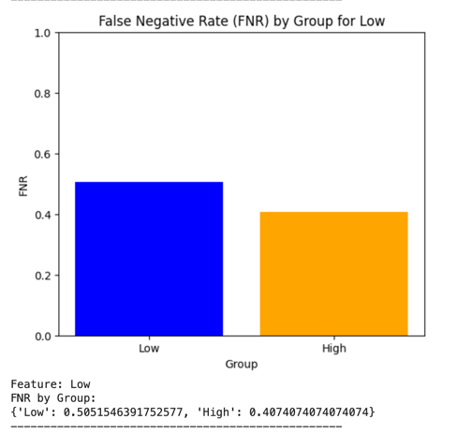

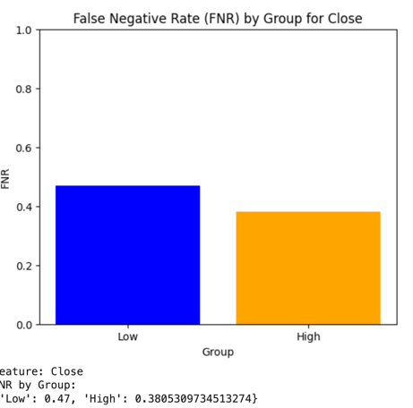

But after finding this, it dose not make that much of sense comparing that the DIR values dose noth show any of bias types but the FNR values show that all the features have bias since there is deference between the values of the FNR of groups.

Using K-means model and dividing the groups into clusters shows that:

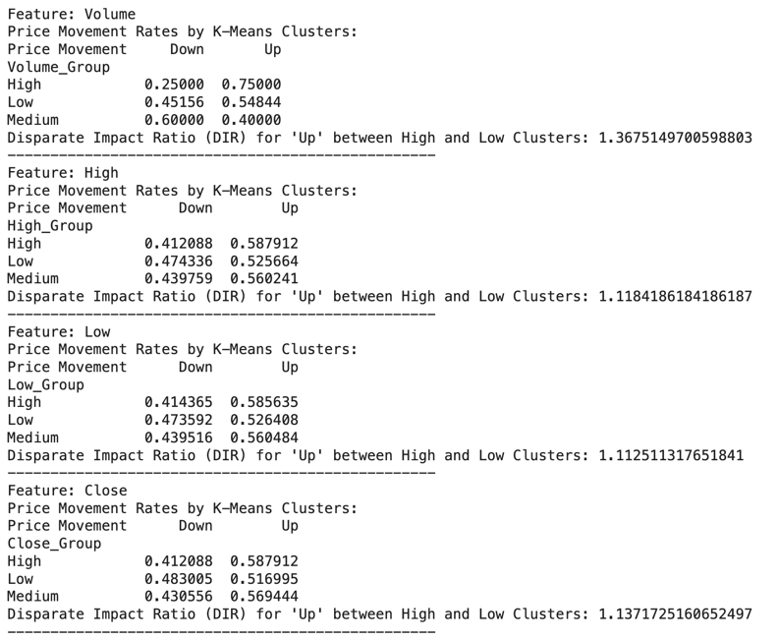

This model shows that the volume column has bias since the value if the DIR is beger than 1.2 but from here I relized that all depends on the way of dividing the group bins of each feature.but I decided to prent the destributuin of the volume colum after deviding it to pins and a found that:

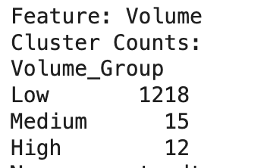

There is a lot of defetance between the instances count of each group, that could be a bias but since the data is not devided equally and also because this column have a lot of outliers I realized that its not bias.

And I can prove this here after running the same model but with removing the outliers from the volume colume we found that there are no degferahnce between the DIR of the groups.

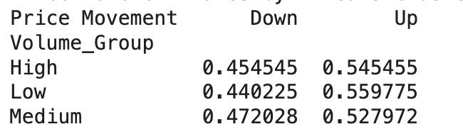

But I decided to see of the target class which is the price movement, have unbalanced classed and I found that there is a little difference in the classes that could be considered as a bias

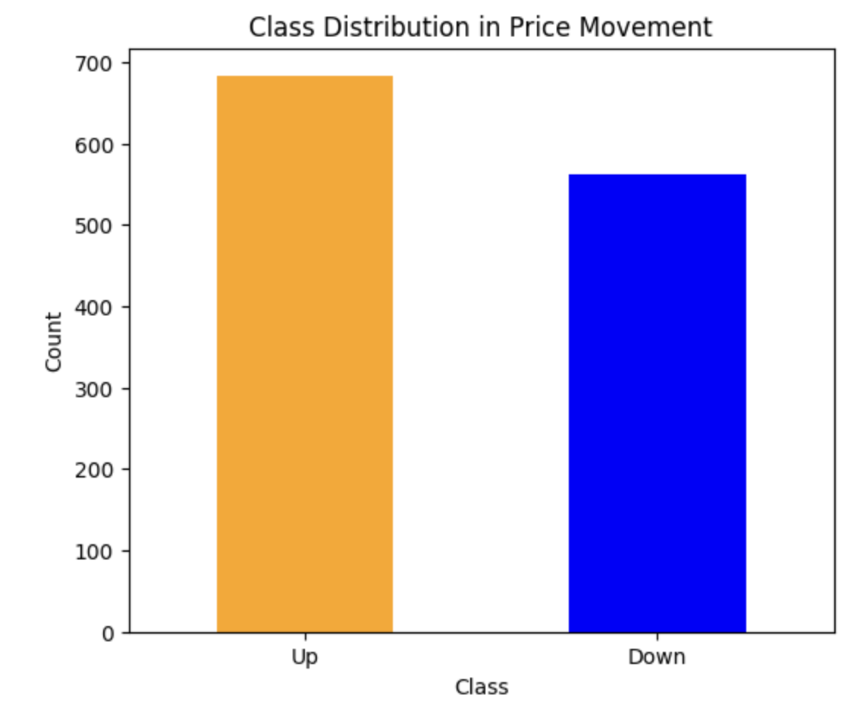

Analysis of whether predictions (e.g., "Up" and "Down") are treated equitably.

Based on the Two models that I have done and all the techniques and also based on if the bins was divided based on quartiles equality there is no bias in all the features that could influence the target feature which is the movemnt price but the movement price feature could have bias since the classes is not balanced.

**Discussion on feature reliance and potential biases detected.**

As we can see from the feature importance the most important feature is the Open, but I did not find any bias in the feature that might affect the prediction of the price movement except that the Price Movement clases are not balanced



As we can see from the SHAPE summary plot that the close was the most feature that the prediction relies on, but it was not that big of a reliance, as some other features like Open was also a great contributor. That matches the results with I did not find bias in the features that might affect the prediction.

Also based on all the Lime plots that are mentioned before, the results of the lime were very close to the results of the shape and the class was the most feature that the predictions on but as I said that I did not found any pias in any feature that might affect the results of prediction exept the price movement classes

## **Adjustments for Optimization**

Summary of adjustments made to improve model performance for mitigate biases. Include hyperparameter tuning, alternative algorithms tested, or feature selection changes.

Before I start the optimization I tried two models to see the preformace before optimization

I used the the random forest and lojestic regrission

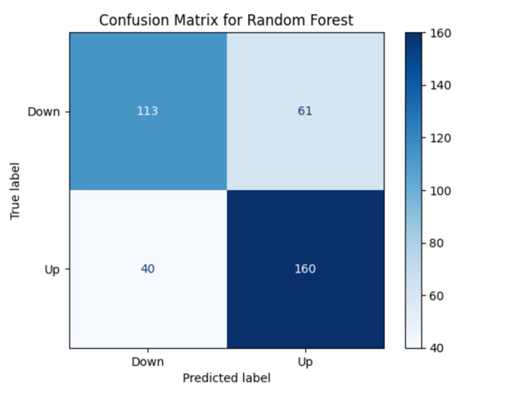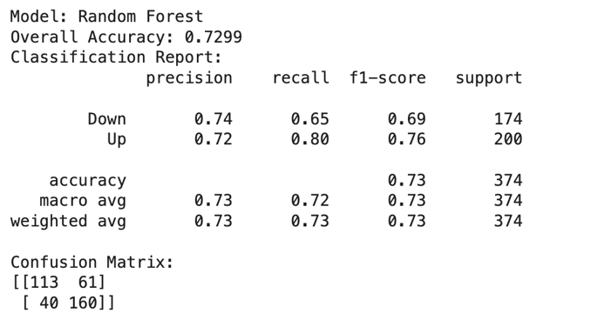

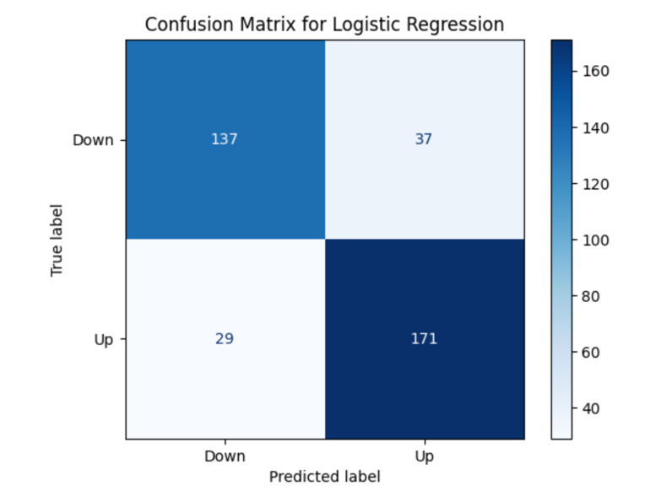

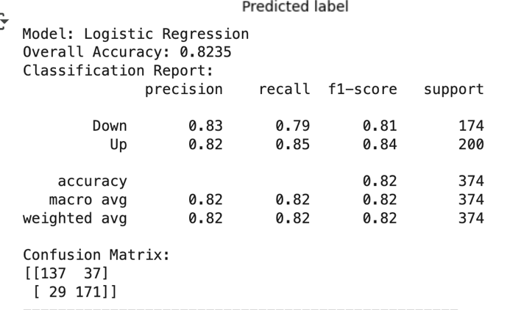

Thern I have used the first optimization method which is considered as preprossing optimization which is the Smote optimization to balance the Price Movemnt classes, and then I used the same models to see if the out put has inhanced.

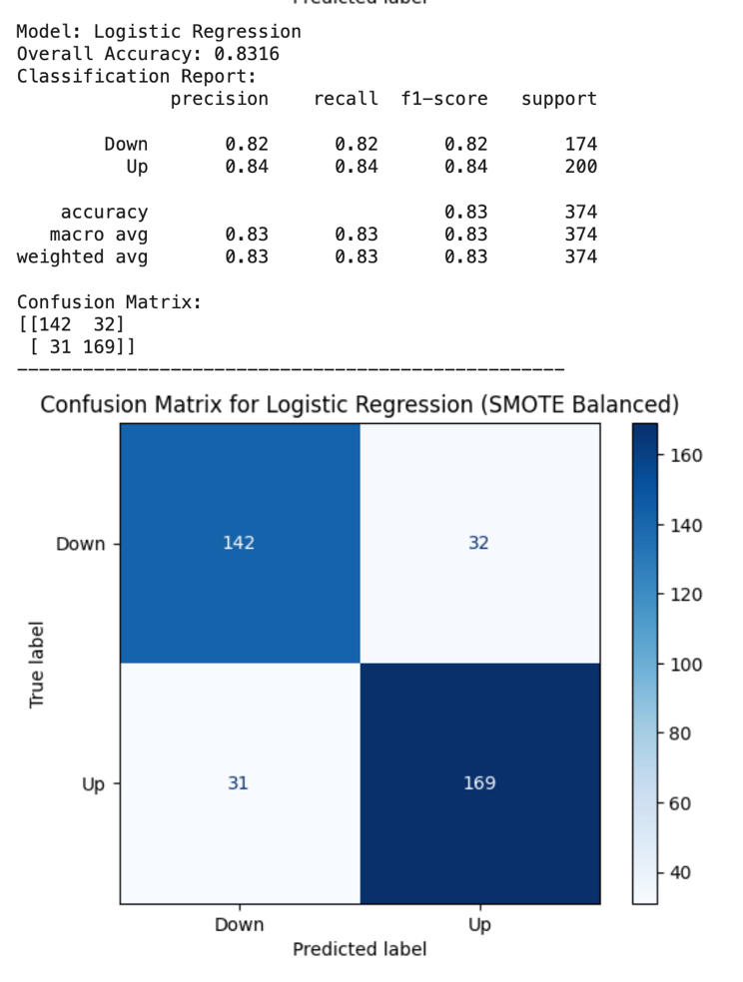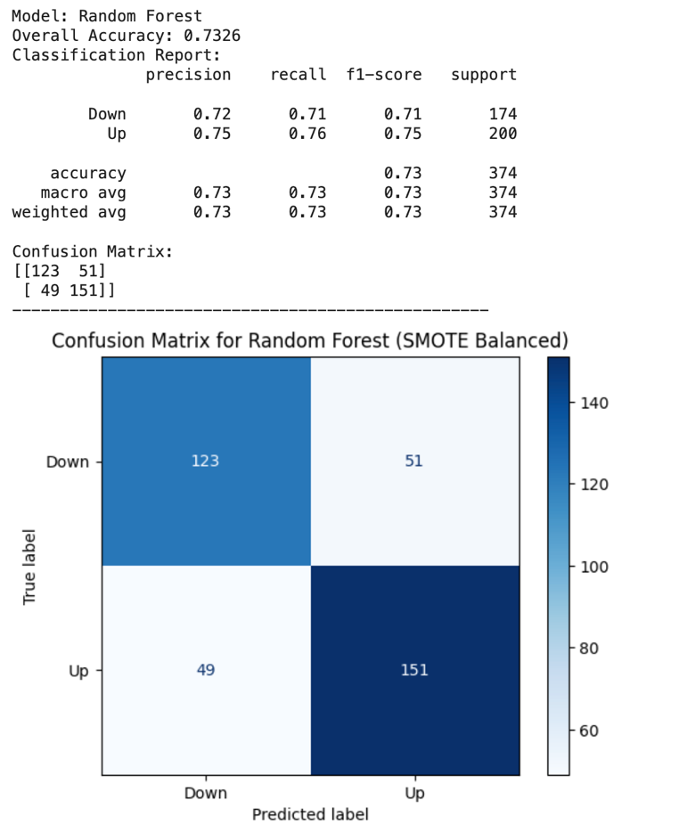

As we can see after we have done the smote the prefomance have improved a lot for both models and we can see this from the classification report and the CM.

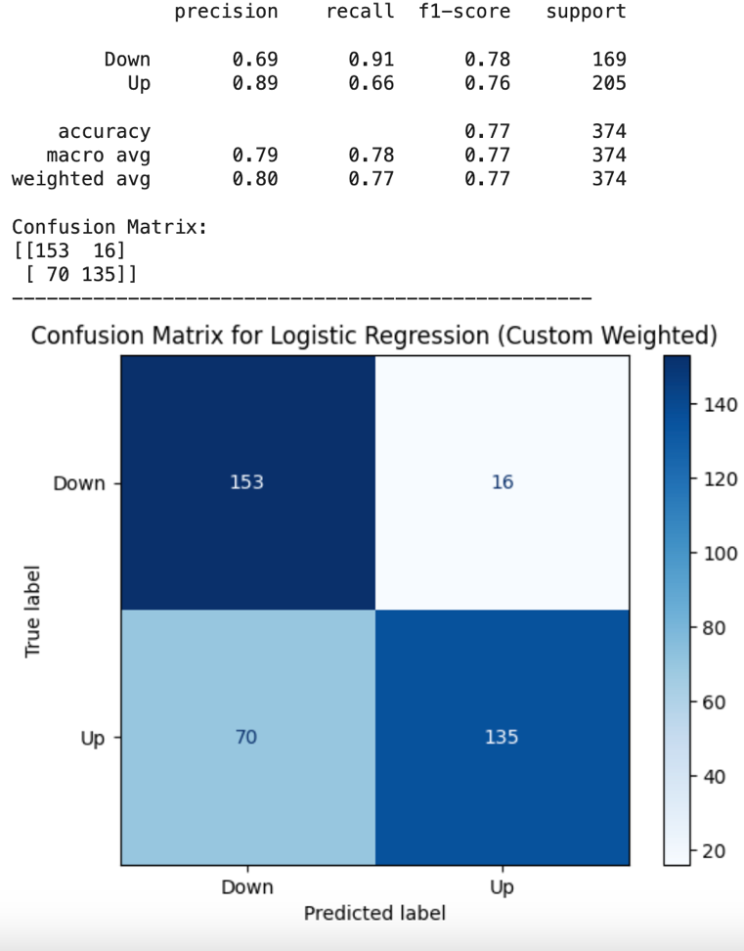Also, I have tried the to do another optimization which considered and in processing which is the custom weighting for the classes but this type of optimization does not improve the performance at all

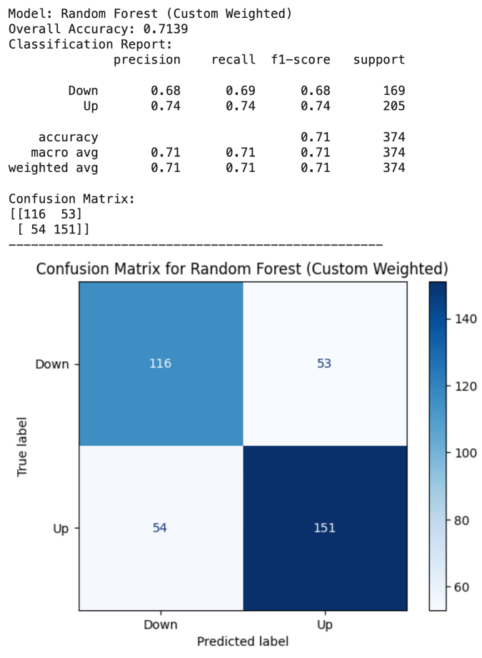

## **Performance Comparison**

Table comparing performance metrics before and after optimization.

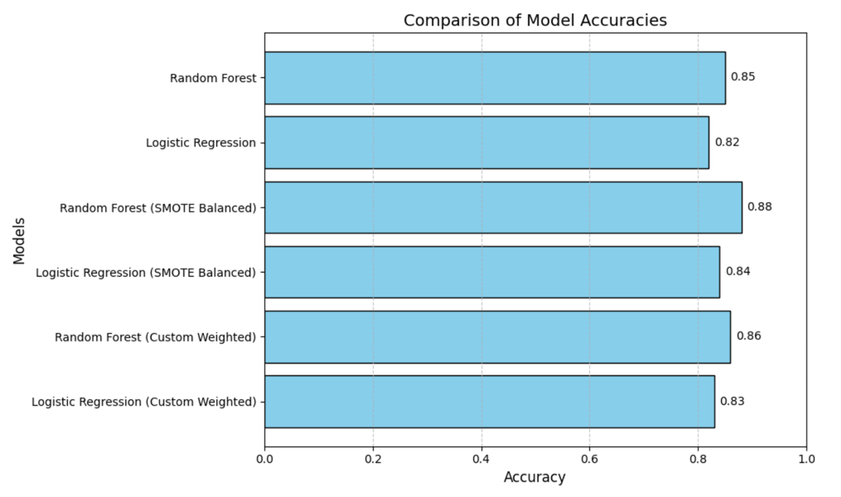Visual Insights

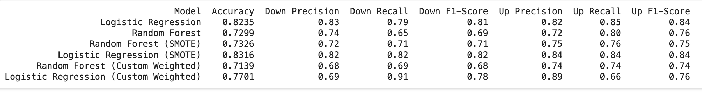

As we can see that I have compared the two models, The first one without optimization the second one with smote, and the third on with customized weighted

The insights that using the smote to balance the Price movement price classes has improved the accuracy a lot, it was the best between the models without optimization and also better than the models with the weighted optimization, but the models with the customized weighted optimization was so bad and these models was the worst than the models with smote and also worst than the model without optimization.

# **Time Series Models**

## **Performance Metrics**

Compare the performance metrics (e.g., MAE, R²) of Prophet and AutoTS models.

|  |  |  |  |  |
| --- | --- | --- | --- | --- |
|  | R2 | MAE | MSE | RMSE |
| Prophet | 0.9730804109849829 | 33.53303264250895 | 1825.7718010826713 | 42.72905102015105 |
| Auto TS | -0.2178576954598339 | 41.37532220523132 | 3017.147893755015 | 54.92857083299196 |

As you can see the Prophet model has achieved higher R2 than the Auto TS model which means the prophet model was able to explain the data and have superior ability to capture patterns and trends.

And also the prophet model have achieved less MAE, MSE, and RMSE which is very better than the AUTO TS model

## **Visualizations**

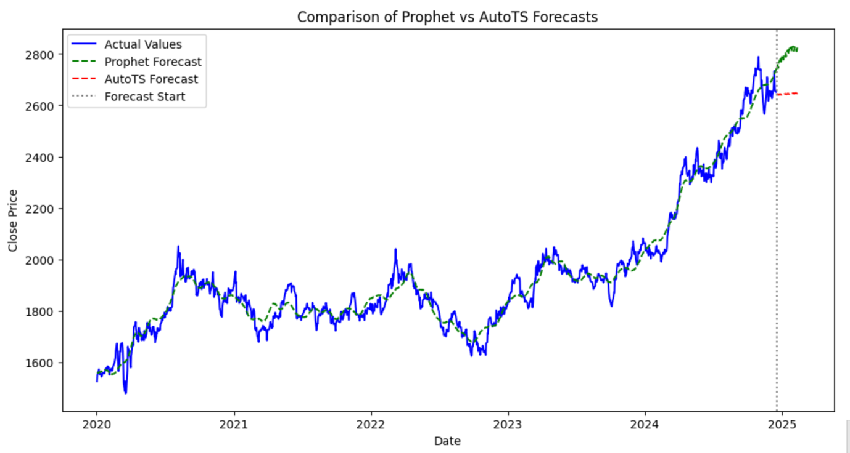Line charts showing comparison of forecasts closing prices Prophet vs AutoTS

## **Model Comparison**

Analyze and compare the performance of the two models based on visualizations and performance metrics. Provide recommendations on which model is more suitable for the task.

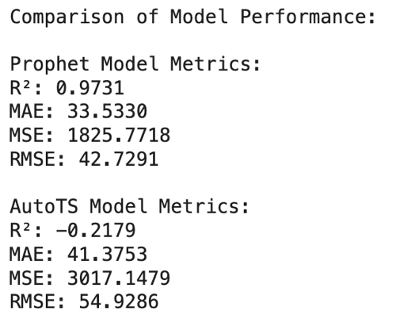

As you can see that the Prophet Model has achieved a very High R2

that it is close to one with a low values of MSE, MAE, and RMSE,

the Prophet model demonstrates excellent performance, this shows that

the Prophet Model was able to catch the patterns.

on the other hand, the Auto TS model has preformed very bad, and we

can see that from the negative value of R2 which indicate that the model

was not able to capture the patterns at all, and also this model achive high

values of MAE, MSE, and RMSE.

Based on the visualization we can see that the Prophet model has been very accurate, and we can prove this from seeing the green line how it follows the actual data exatly in tha past years which endecates that this model has catch all the patterns in the data, and also we can see that the prediction period (the end of the green line) it makes since to the pattern of the data

But for the Auto TS model as we can see it is so far from the the actual data to level that its predections is not show in the graph and that’s prove how much this model is bad to a level that we can imagine, also the prediction after the line of the forcast start show that it is too far from the pattern of the actual data and also too far from the Prophet model prediction.

I recommend to use the Prophet Model instead of using Auto TS model:

The Prophet model is more suitable for this this dataset because it gave me a very high R2 and small values of MSE, MAE, and RMSE, which shows that this model have the abilty to deal very well with this dataset and capture all the patterns in the dataset, also the Prophet model's forecast aligns closely with the actual data, both historically and in the prediction period, making it reliable for this task.

But the Auto TS Model have preformed very poor and weak which we can see that from the negative value of R2 and the high values of MSE, MAE, RMSE, which show that this model do not have the ability to capture any of the data patterns or trends, but I also recommend next time to do hyperparameter tuning for this model and see the results.

# **References**

Provide a list of references in Harvard format.

Task1:

1.1

<https://insights.exness.com/trading-basics/Top-20-trading-indicators-to-master-the-markets/>

[https://www.metastock.com/customer/resources/taaz/?p=93#:~:text=The%20PVT%20is%20calculated%20by,*%2010%2C000)%20to%20the%20PVT](https://www.metastock.com/customer/resources/taaz/?p=93#:~:text=The%20PVT%20is%20calculated%20by,*%2010%2C000)%20to%20the%20PVT).

<https://chartschool.stockcharts.com/table-of-contents/technical-indicators-and-overlays/technical-indicators/commodity-channel-index-cci>

<https://medium.com/@huzaifazahoor654/how-to-calculate-cci-in-python-a-step-by-step-guide-9a3f61698be6#:~:text=The%20CCI%20Formula&text=Typical%20Price%20%3D%20(High%20%2B%20Low,of%20absolute%20deviations%20from%20SMA>

<https://www.investopedia.com/terms/c/commoditychannelindex.asp>

Task2:

2.1  
<https://developers.google.com/machine-learning/gan#:~:text=Generative%20adversarial%20networks%20(GANs)%20are,belong%20to%20any%20real%20person>.

2.2

<https://aws.amazon.com/what-is/gan/>

<https://www.geeksforgeeks.org/generative-adversarial-network-gan/>

Task3:

<https://www.google.com/search?q=Market+Condition%22+(Bearish%2C+Neutral%2C+Bullish)&rlz=1C5CHFA_enJO1008JO1010&oq=Market+Condition%22+(Bearish%2C+Neutral%2C+Bullish)&gs_lcrp=EgZjaHJvbWUyBggAEEUYOTIHCAEQIRigATIHCAIQIRigAdIBBzM2MGowajeoAgiwAgE&sourceid=chrome&ie=UTF-8#fpstate=ive&vld=cid:254d7075,vid:kn-sabk8y2A,st:0>

Task 5:

5.2:

<https://www.datacamp.com/tutorial/explainable-ai-understanding-and-trusting-machine-learning-models>